**I. Resources**: C# , Reactjs , SQL Server

Server Backend : <http://206.189.91.35:7117/swagger/index.html>

Server Front-end : <http://206.189.91.35/>

Clone github FE : <https://github.com/Huu-Quang/Timeshare-management-FE.git>

Clone github BE : <https://github.com/nguyen-hoang-Nnam/Timeshare-Management-BE.git>

Clone folder SWT :

<https://github.com/DuongDucManh/SWT>

Run SQL :

1. Username : sa
2. Password : Abc@123123

**II. API endpoint and How to run?**

**Đức Anh:** [**https://documenter.getpostman.com/view/33379462/2sA2xmTqRN**](https://documenter.getpostman.com/view/33379462/2sA2xmTqRN) **Tiến:** [**https://documenter.getpostman.com/view/33379617/2sA2xmTqRM**](https://documenter.getpostman.com/view/33379617/2sA2xmTqRM)

**Mạnh:**

[**https://documenter.getpostman.com/view/33379345/2sA2xk2Bu9**](https://documenter.getpostman.com/view/33379345/2sA2xk2Bu9)

**Quang:**

[**https://documenter.getpostman.com/view/33168447/2sA2xk2ByZ**](https://documenter.getpostman.com/view/33168447/2sA2xk2ByZ)

**Phong:**

[**https://documenter.getpostman.com/view/33383625/2sA2xmUAg4**](https://documenter.getpostman.com/view/33383625/2sA2xmUAg4)

**Vinh:**

[**https://documenter.getpostman.com/view/33379626/2sA2xmUAbd**](https://documenter.getpostman.com/view/33379626/2sA2xmUAbd)

**Authentication**

1.API Register (POST)

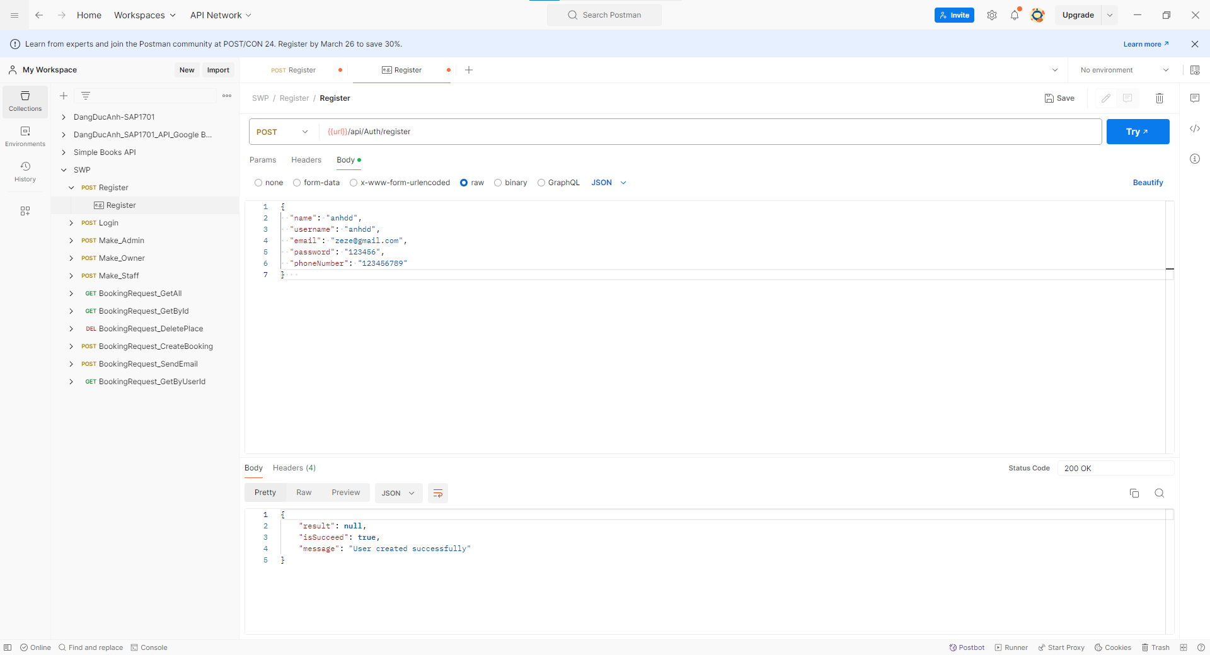

2. API Login (POST)

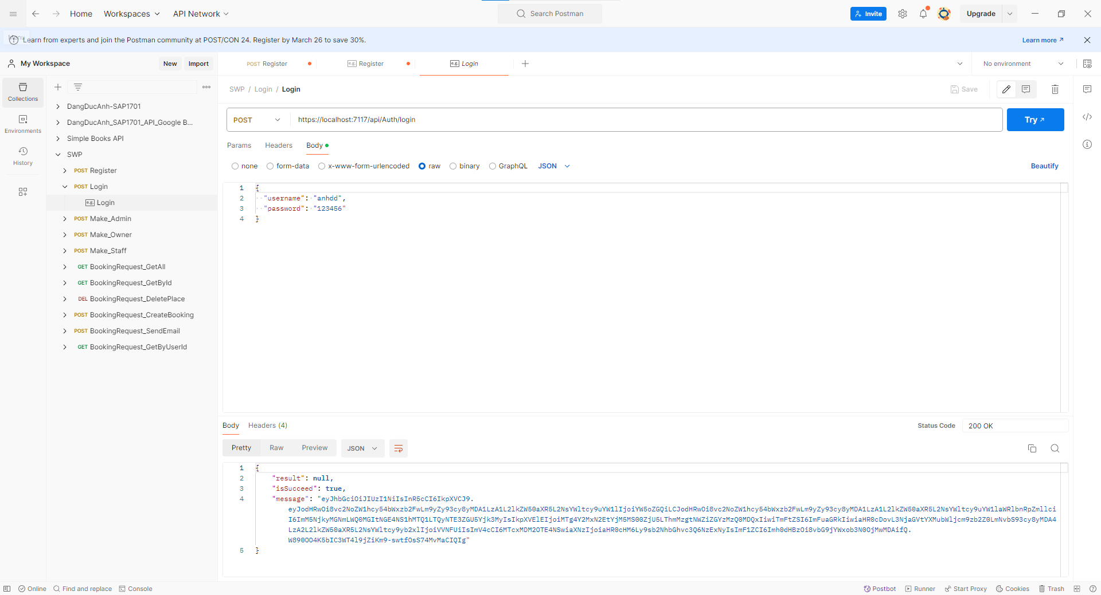

3. API Make_Admin (POST)

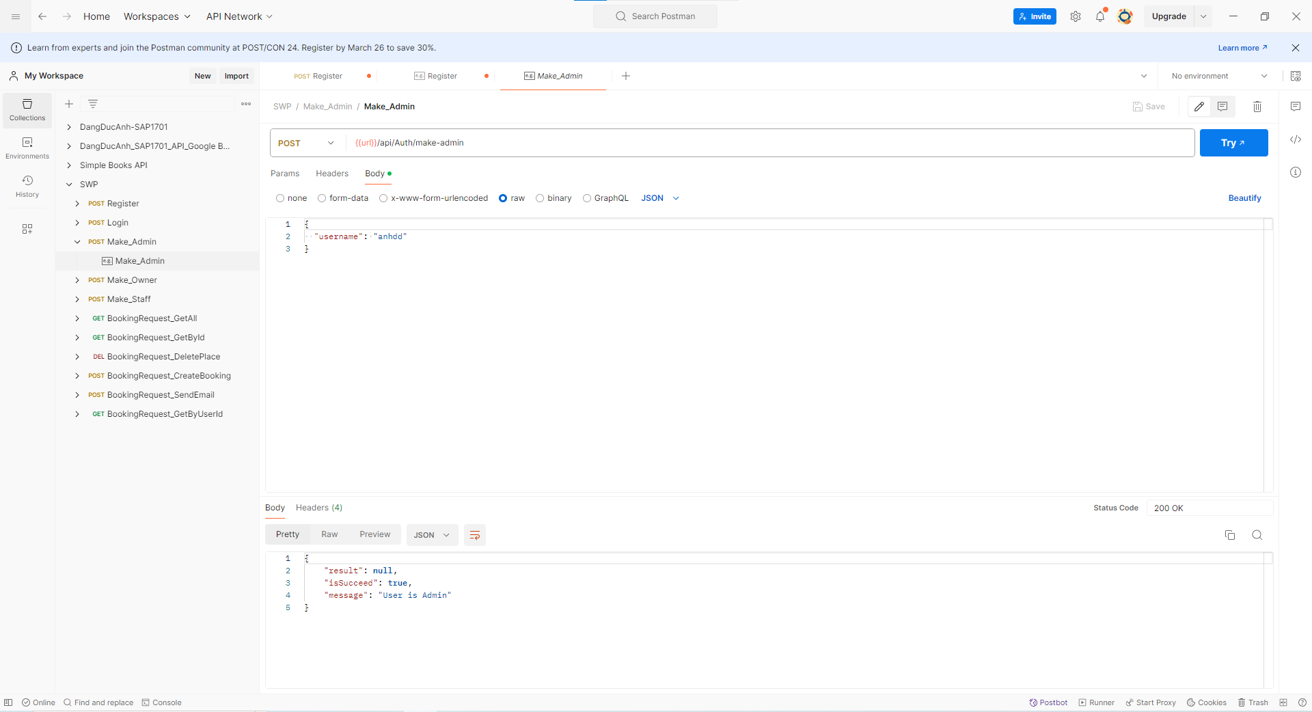

4.API Make_Owner (POST)

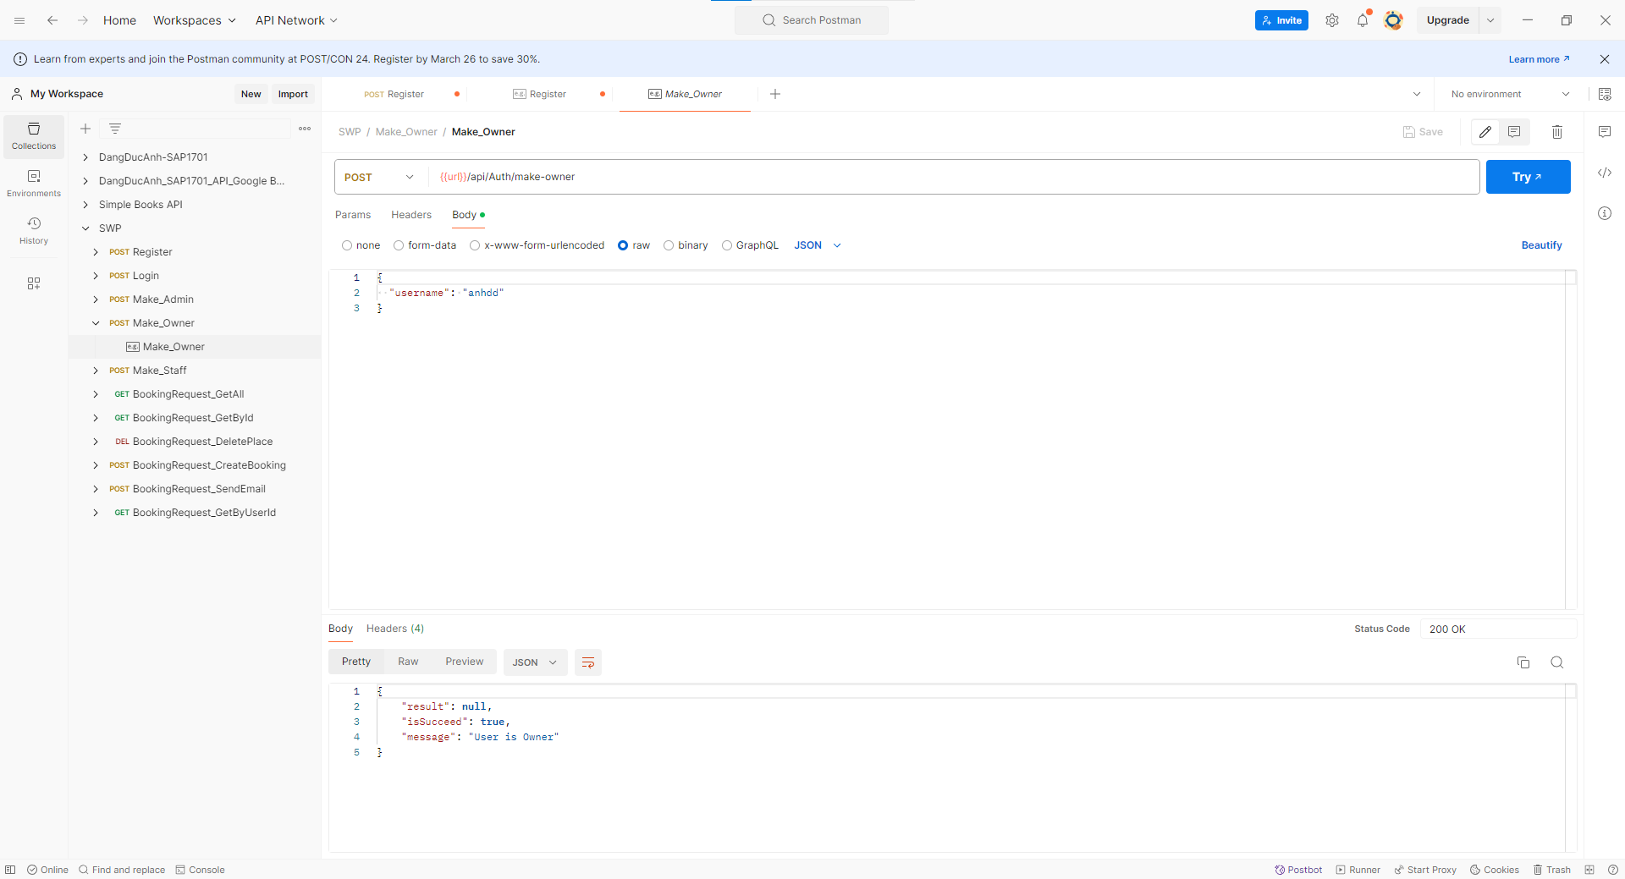

5. API Make_Staff (POST)

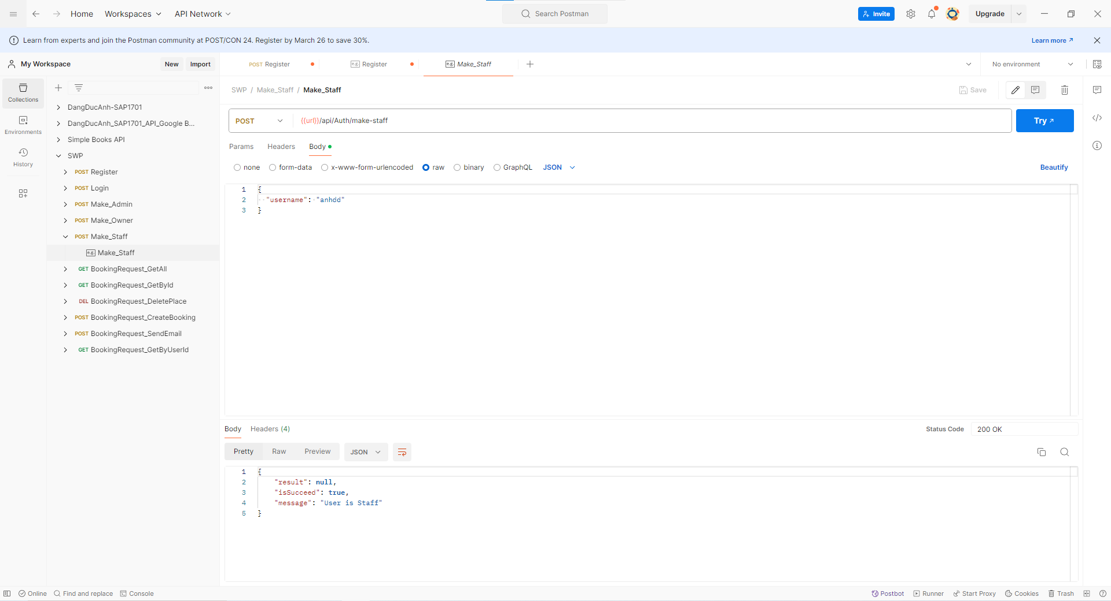

**Booking Request**

7. API GetAll (GET)

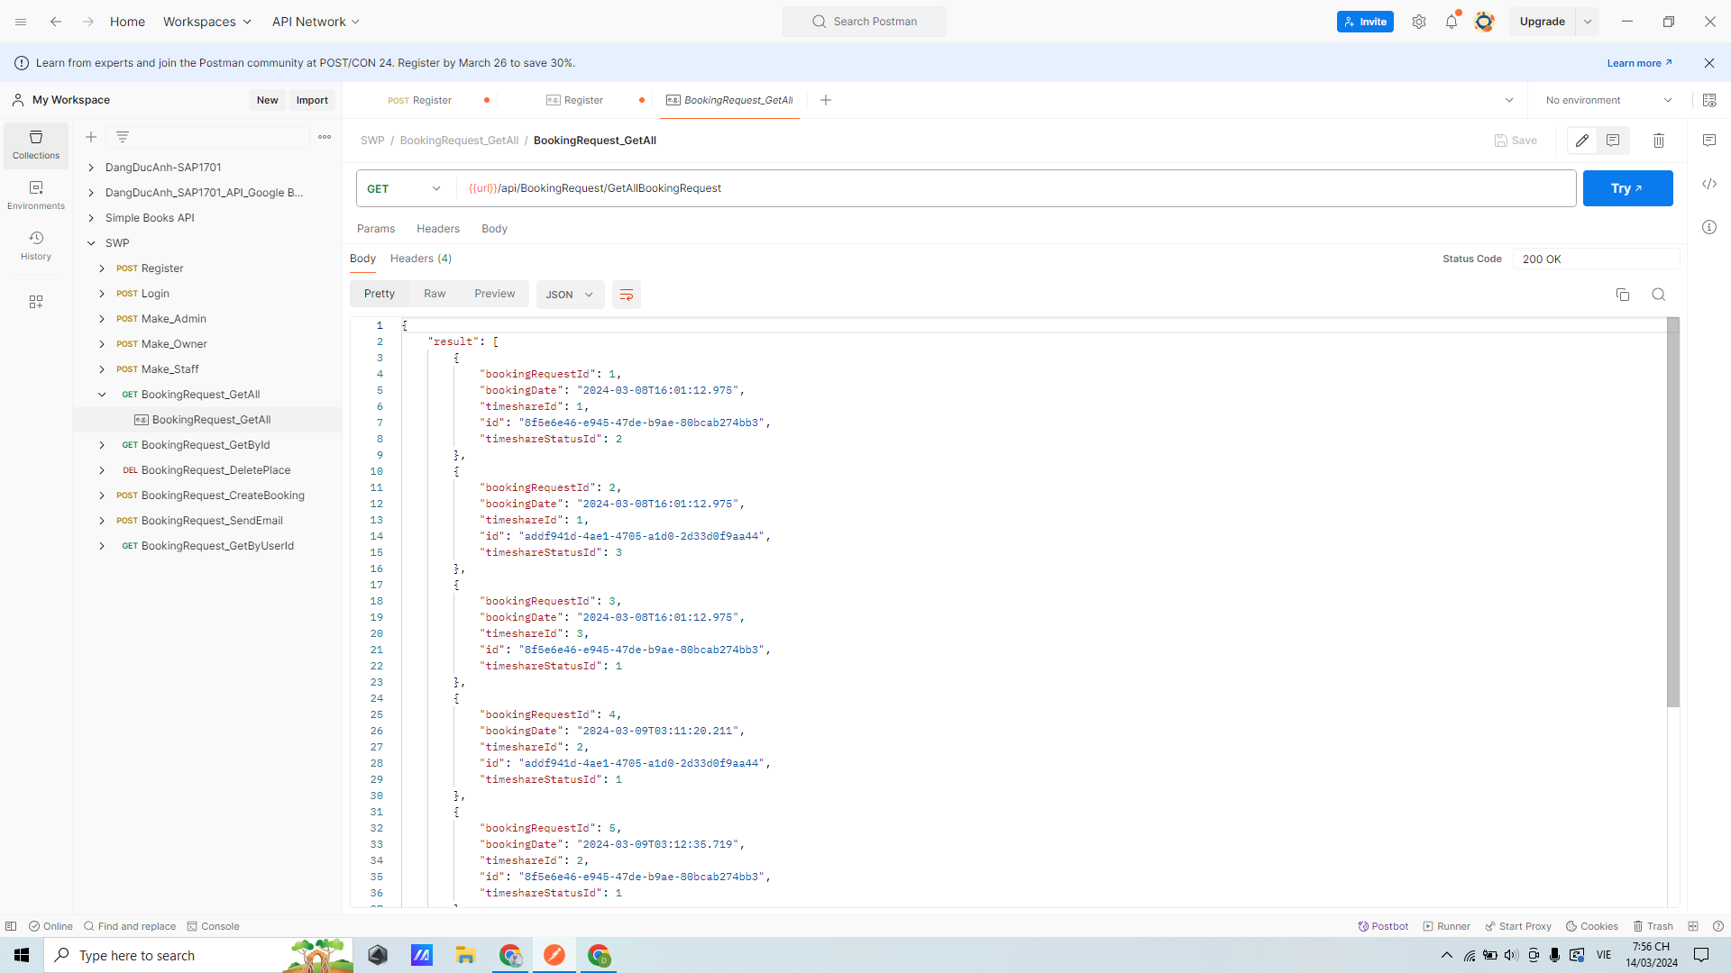

8. API GetById (GET)

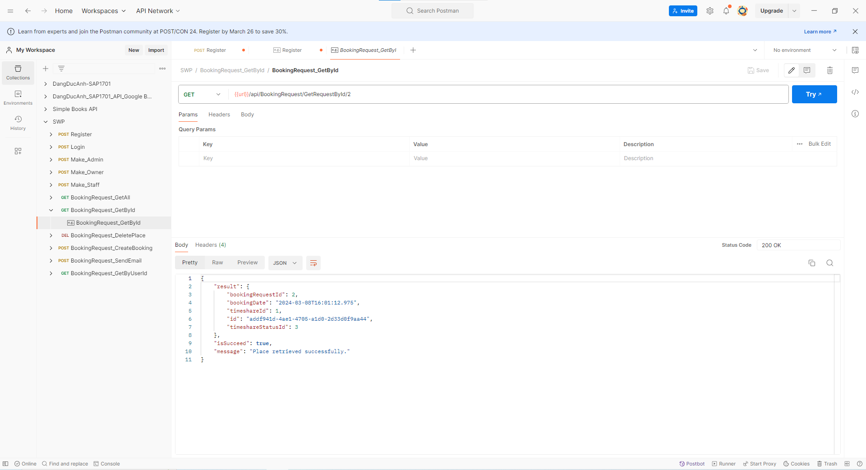

9.API DeletePlace (DELETE)

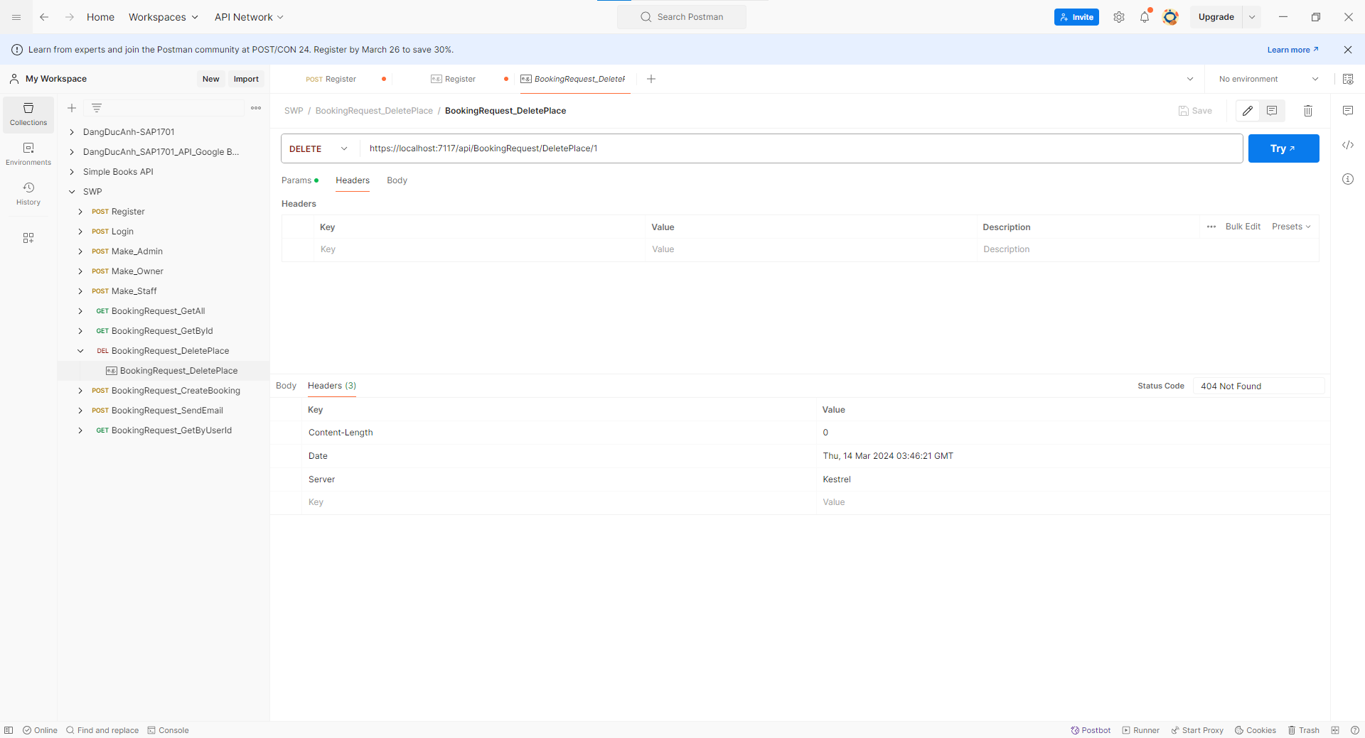

10. API CreateBooking(POST)

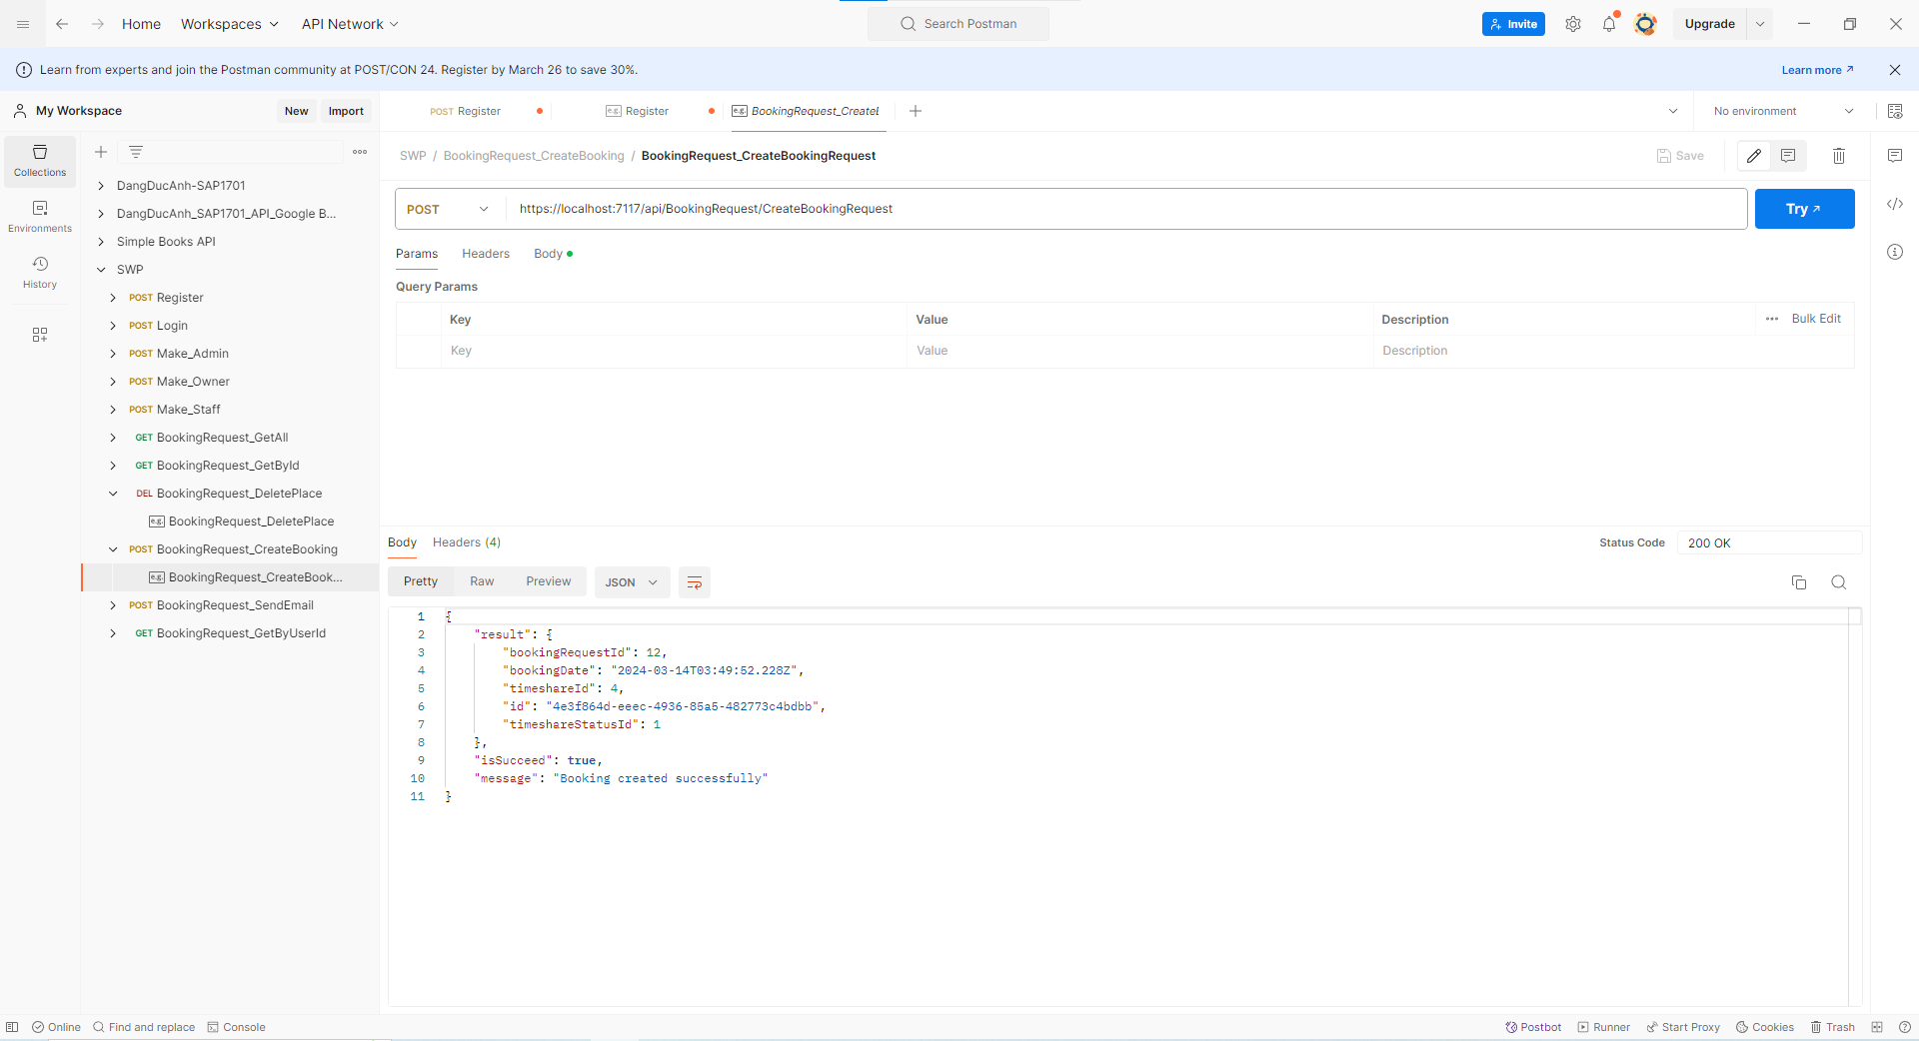

11. API SendEmail (POST)

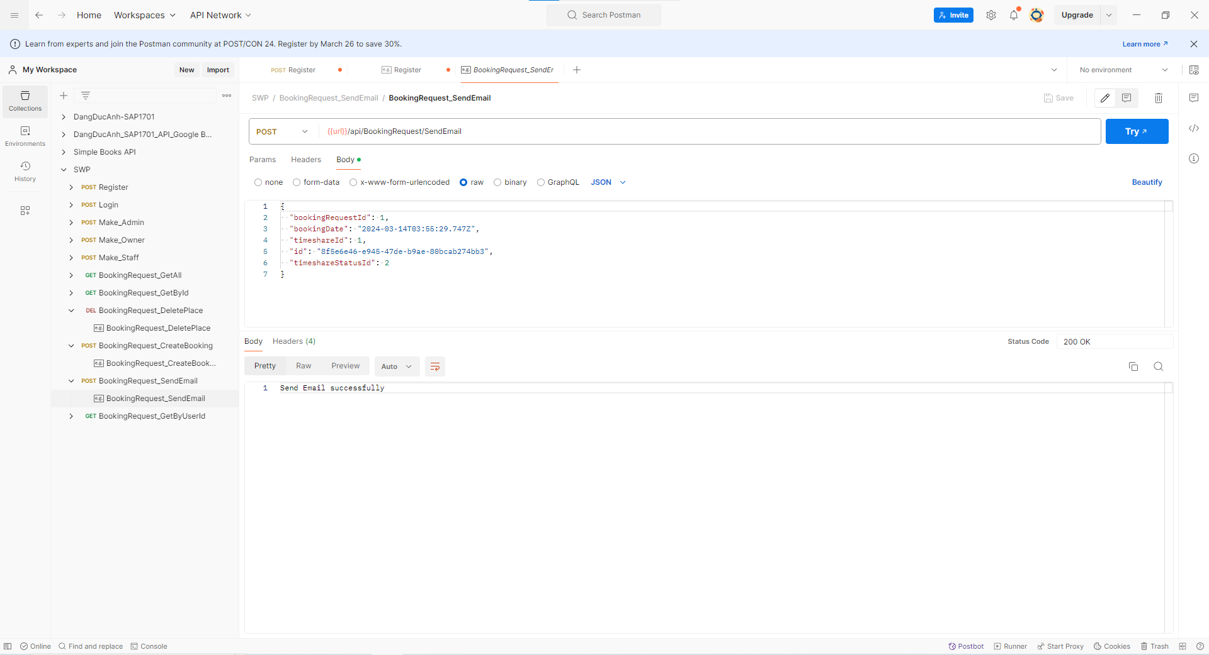

12. API GetBookingByUserId (Get):

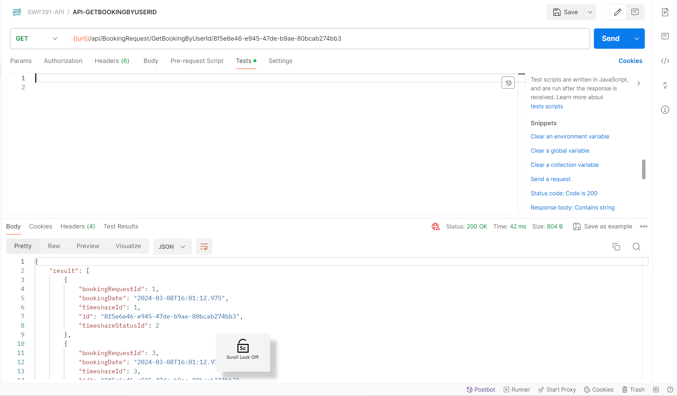

13. API GetBookingByStatus (Get):

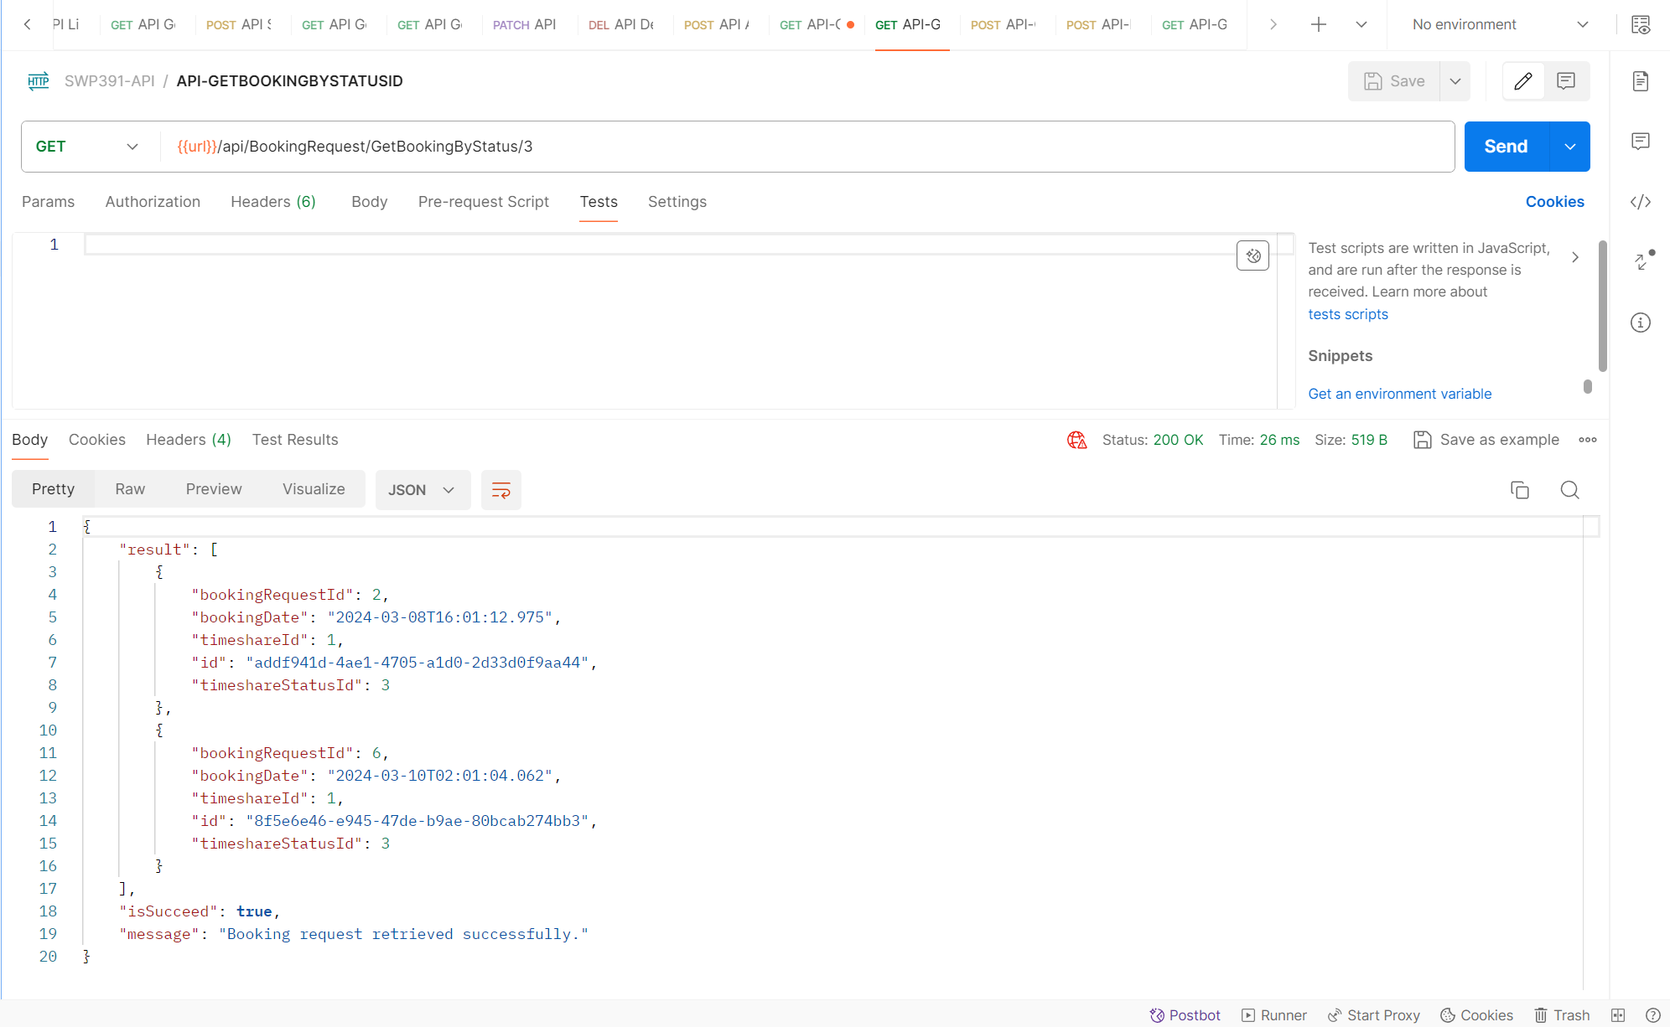

14. API ConfirmBooking (Post):

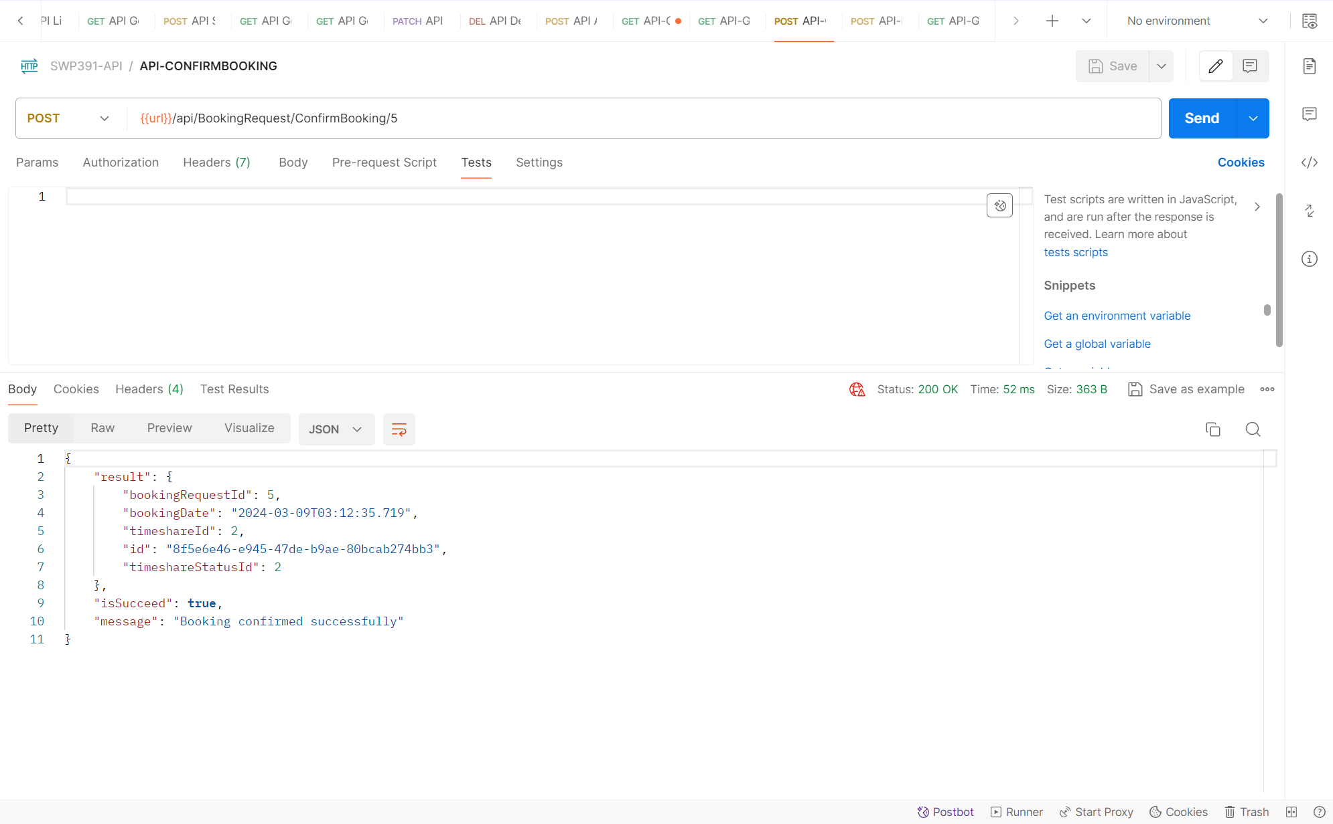

15. API DeclineTimeshare (Post):

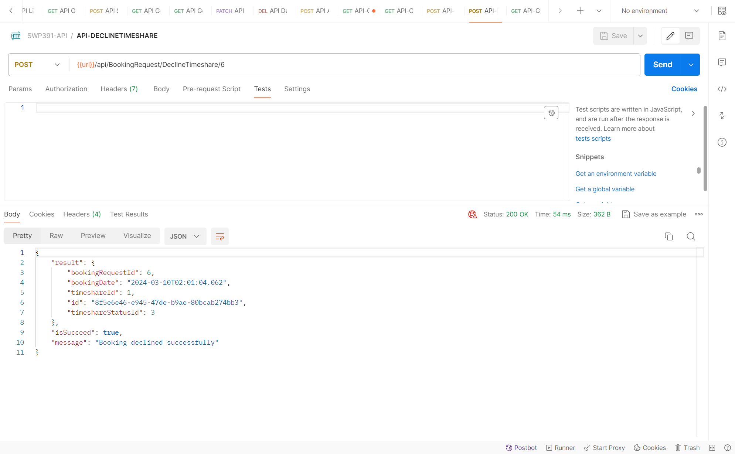

16. API BookingRequest/GetBookingByTimeshare (Get):

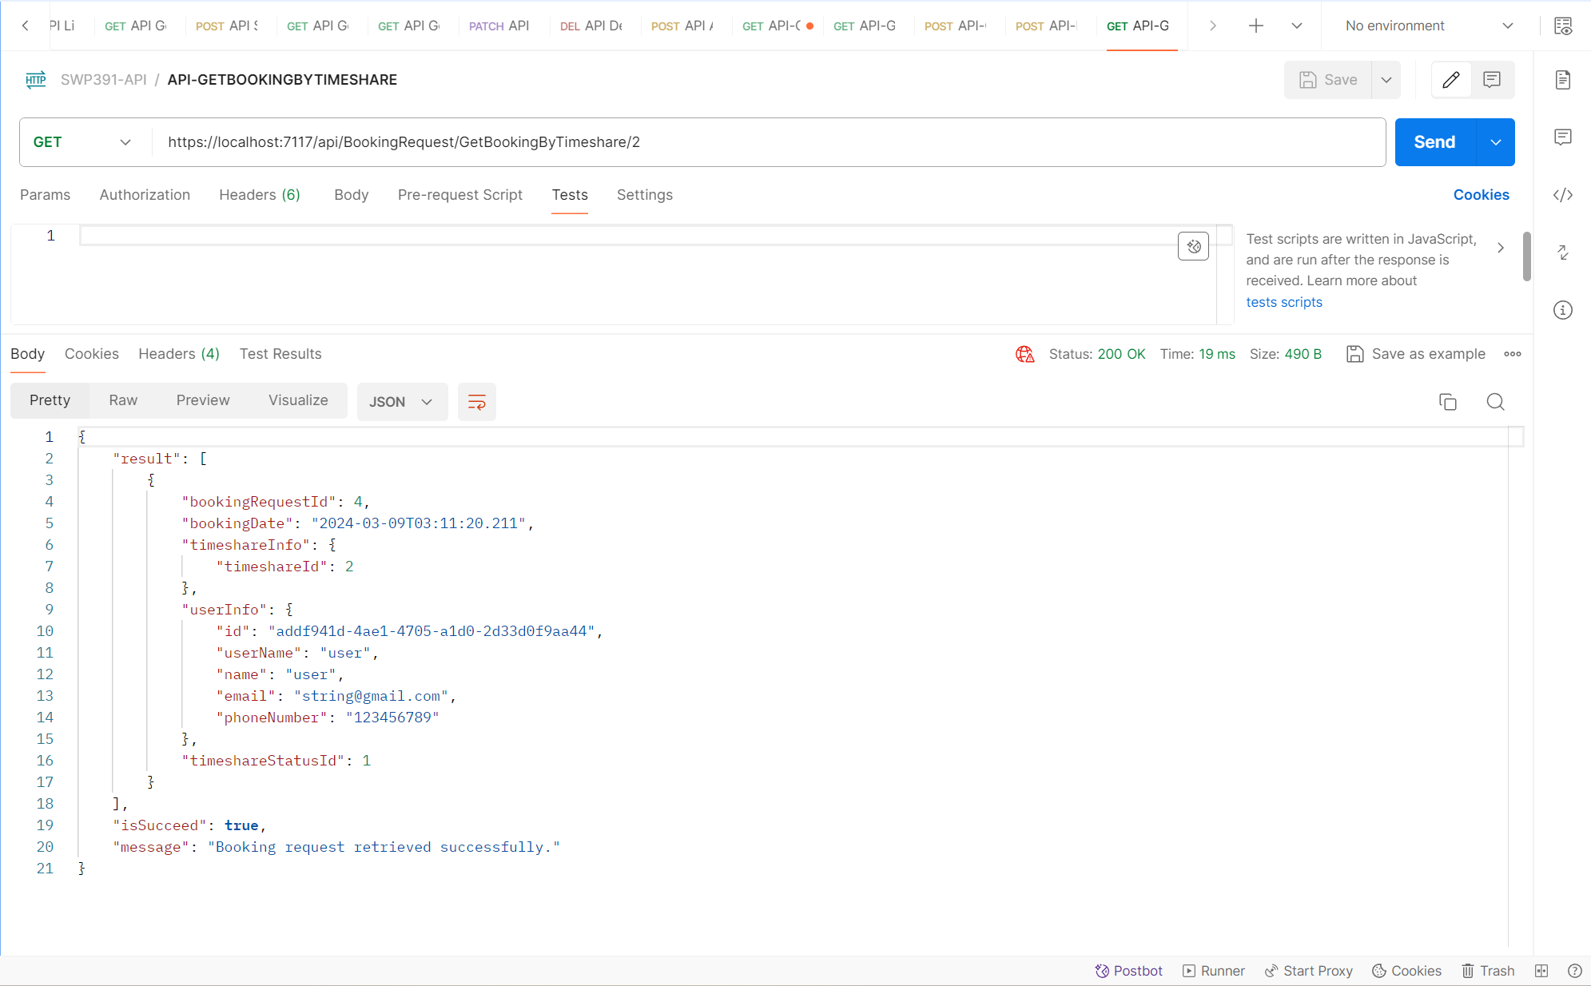

**Place**

17.API-GetAllPlace

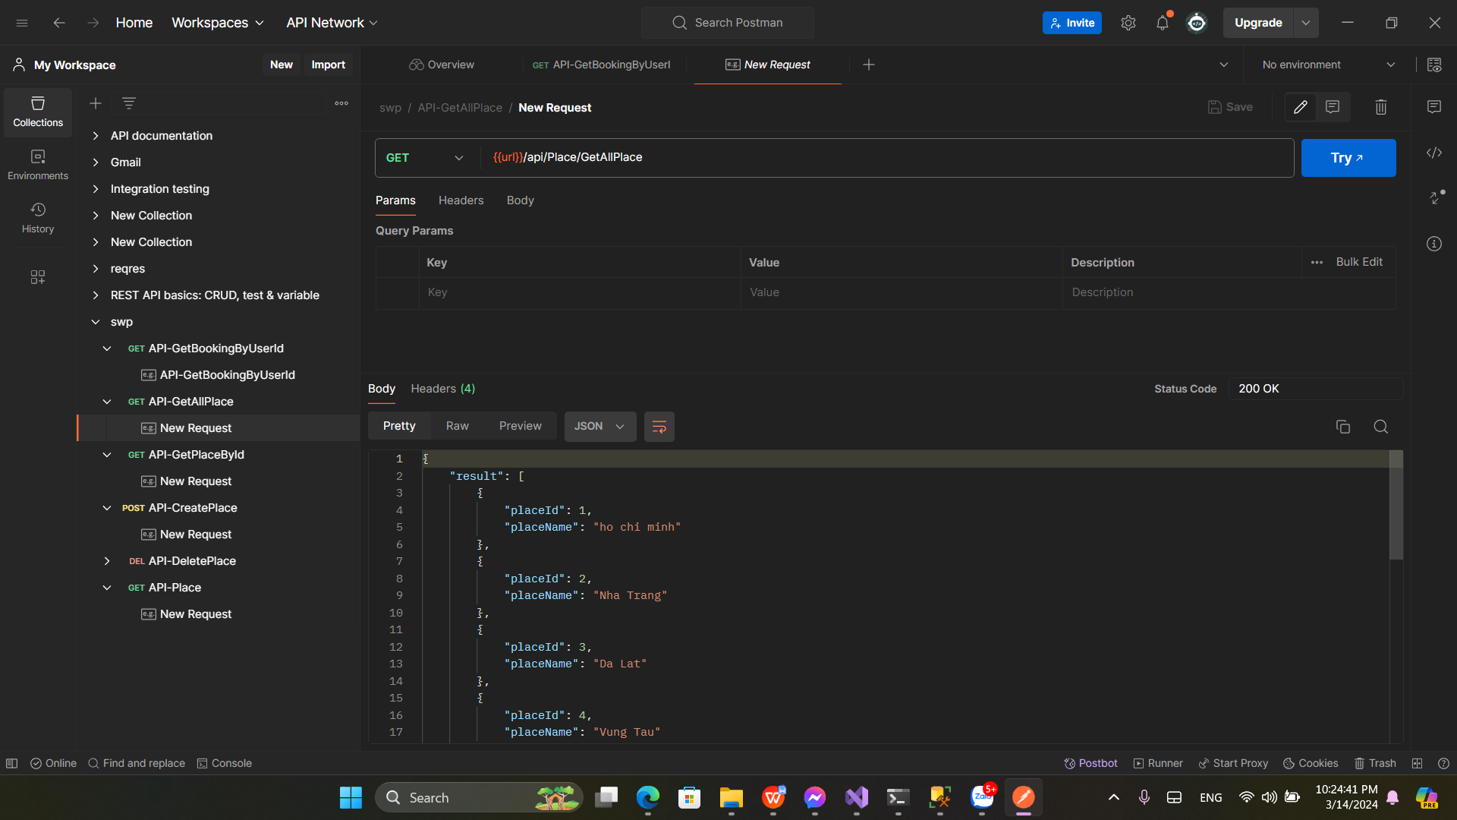

18.API-GetPlaceById

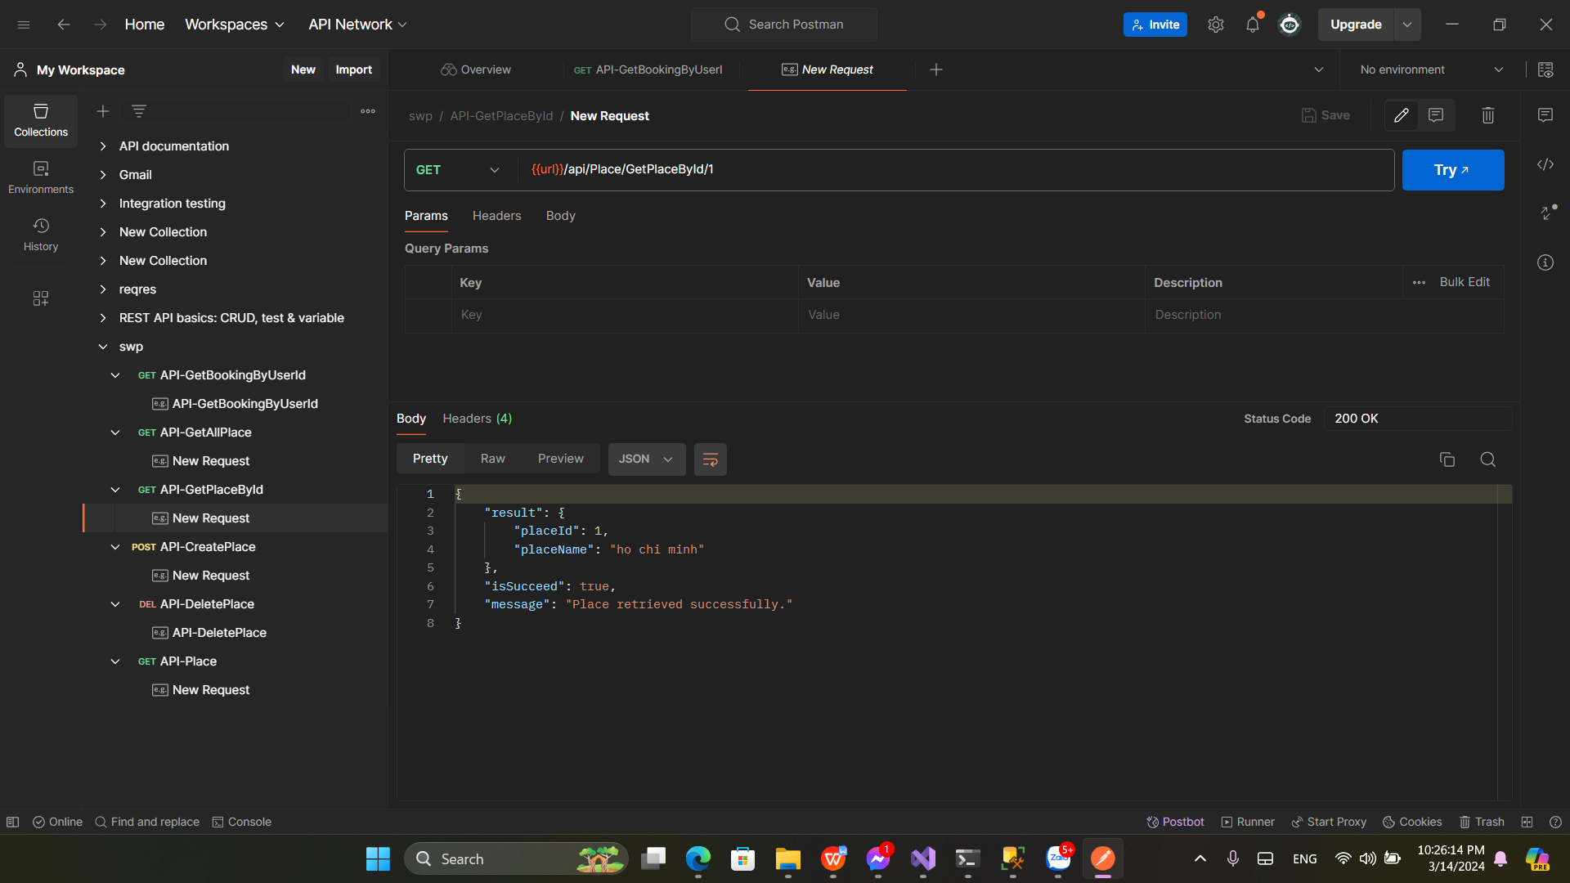

19.API-CreatePlace

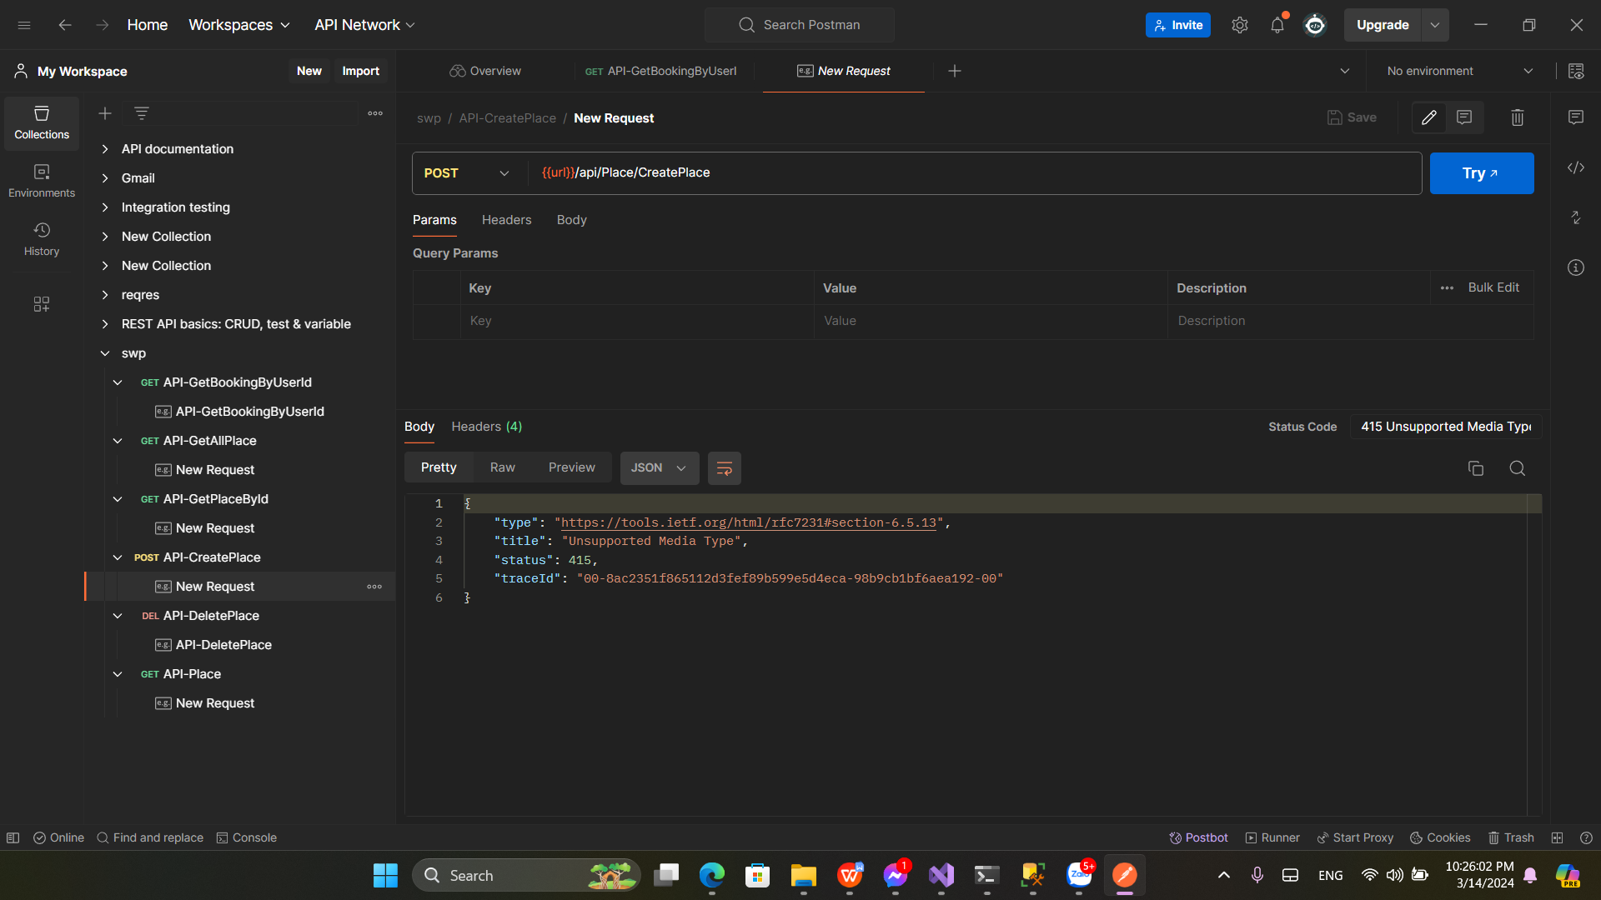

20.API-DeletePlace

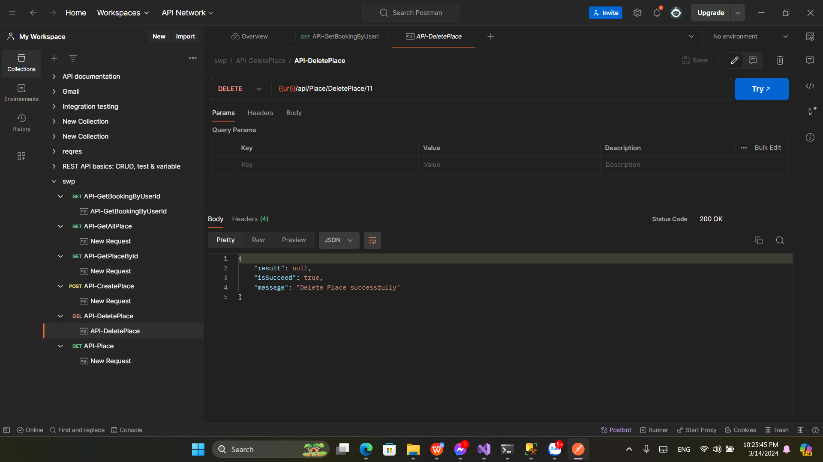

21.API-Place

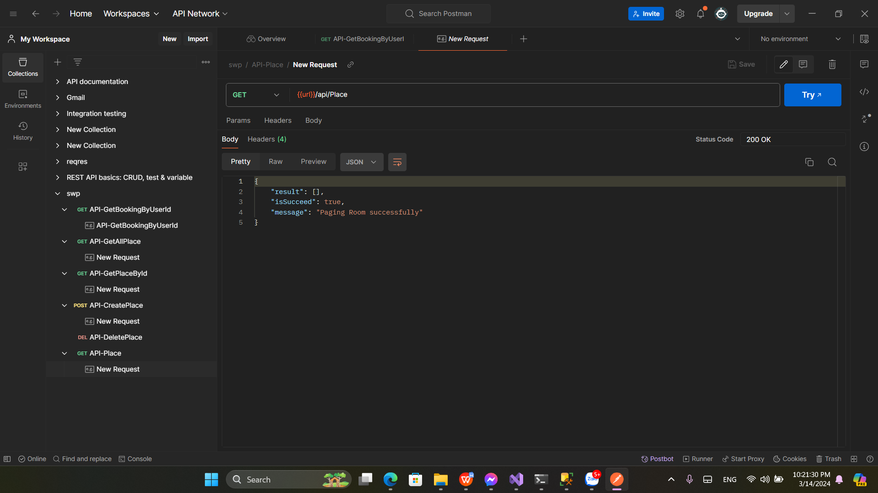

**Timeshare**

22. Get all timeshare:

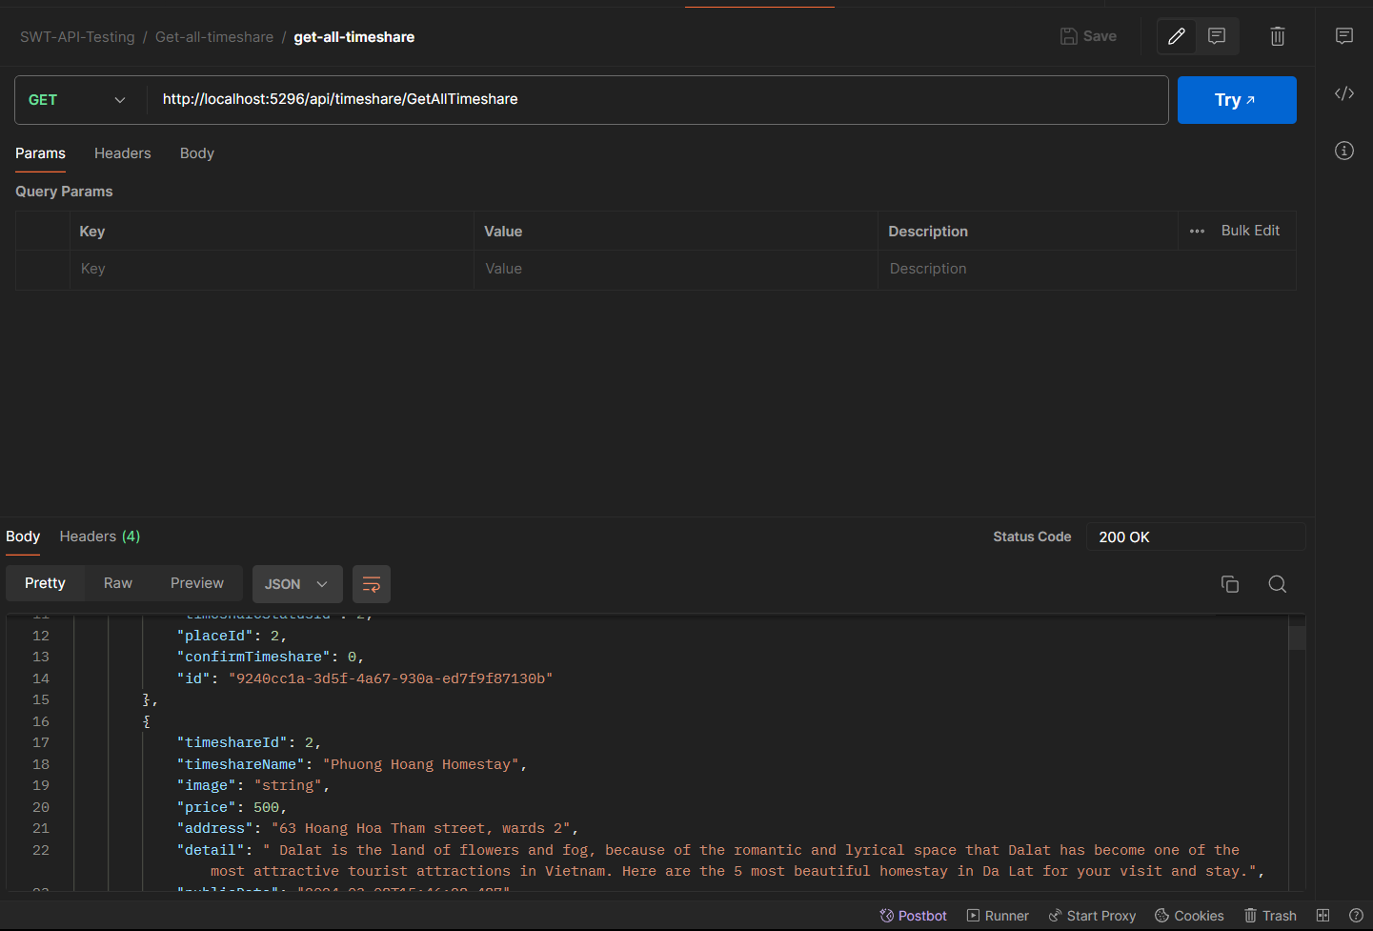

23.Get timeshare by user id:

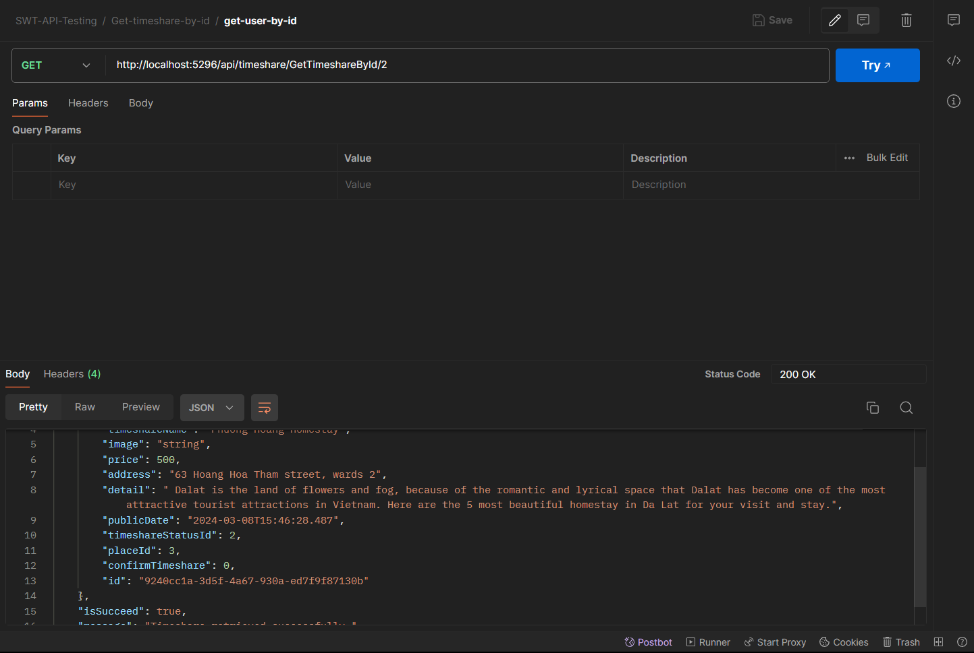

24. Paging timeshare:

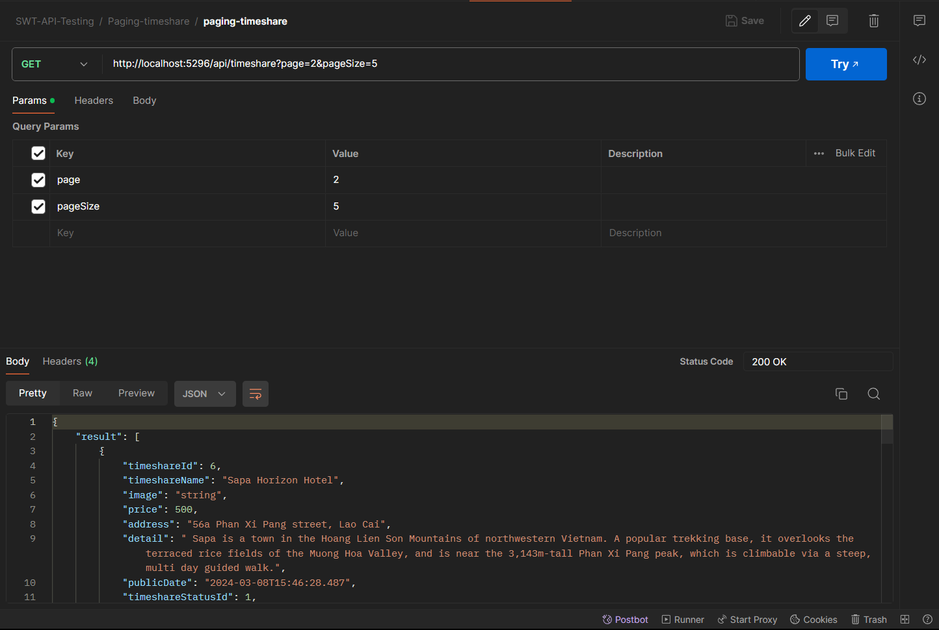

25. Confirm timeshare by id:

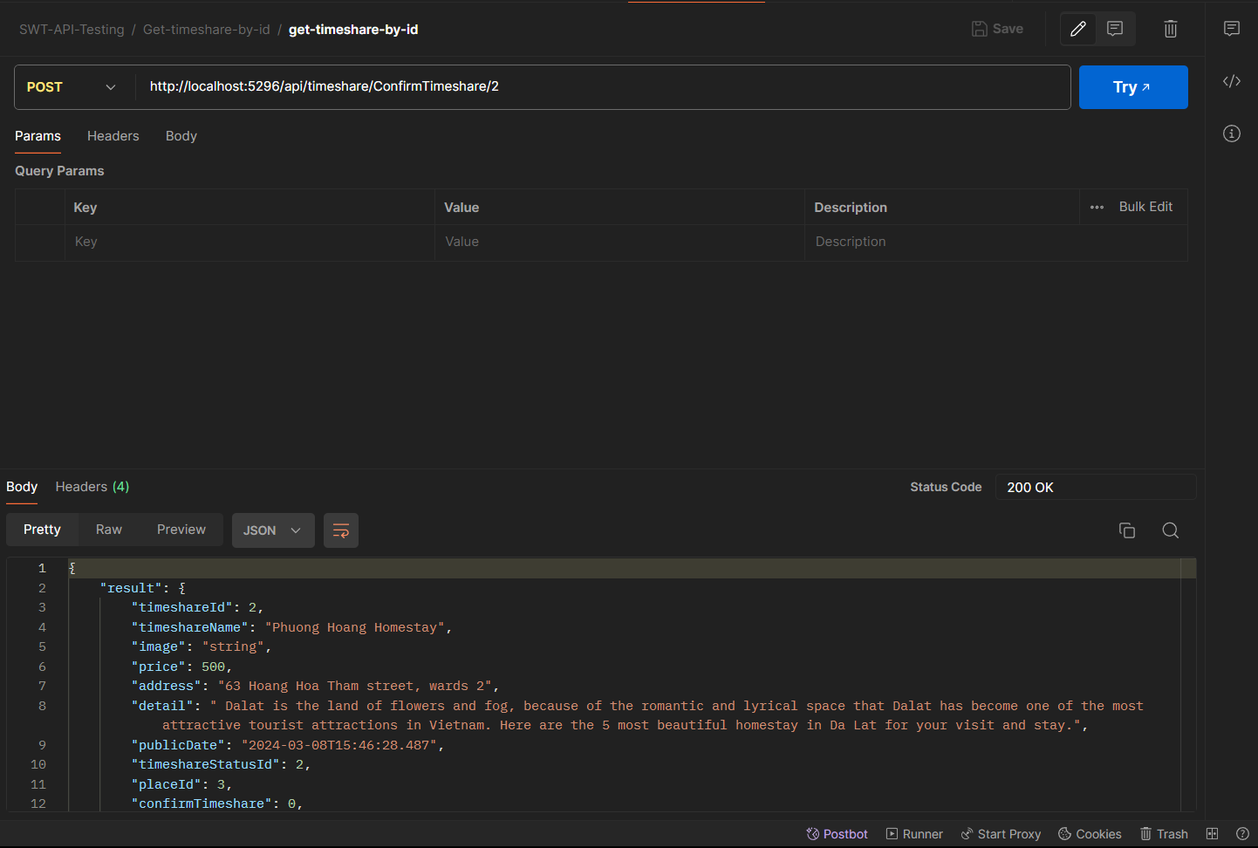

26.Get timeshare by status id:

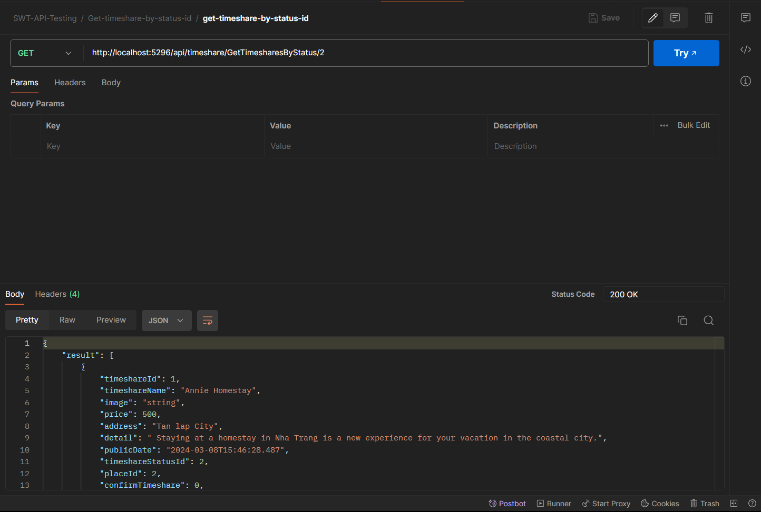

27. Get timeshare by user id:

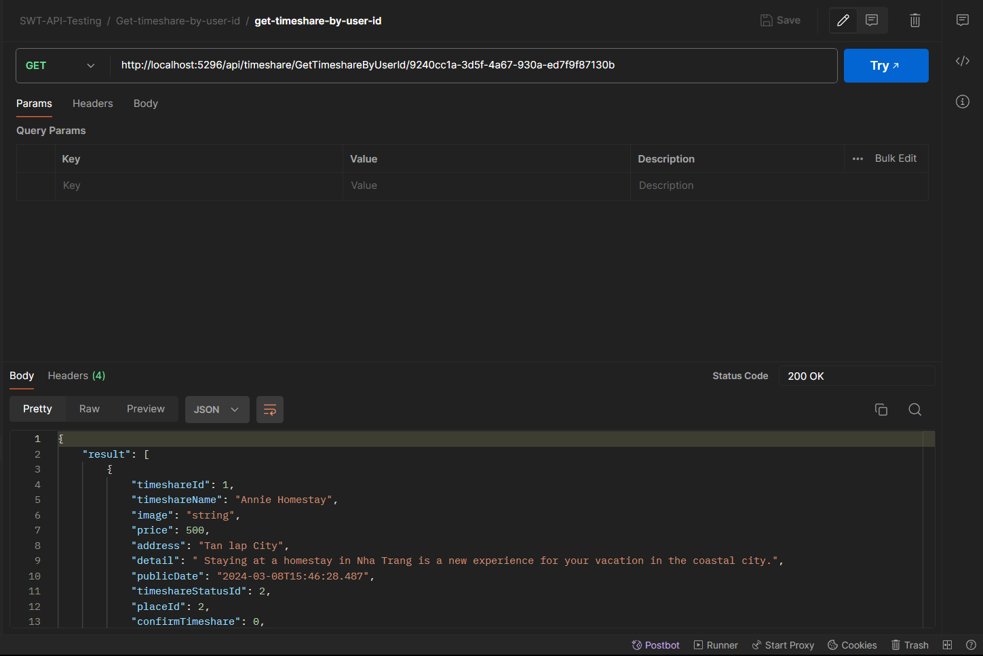

28.Get active timeshare:

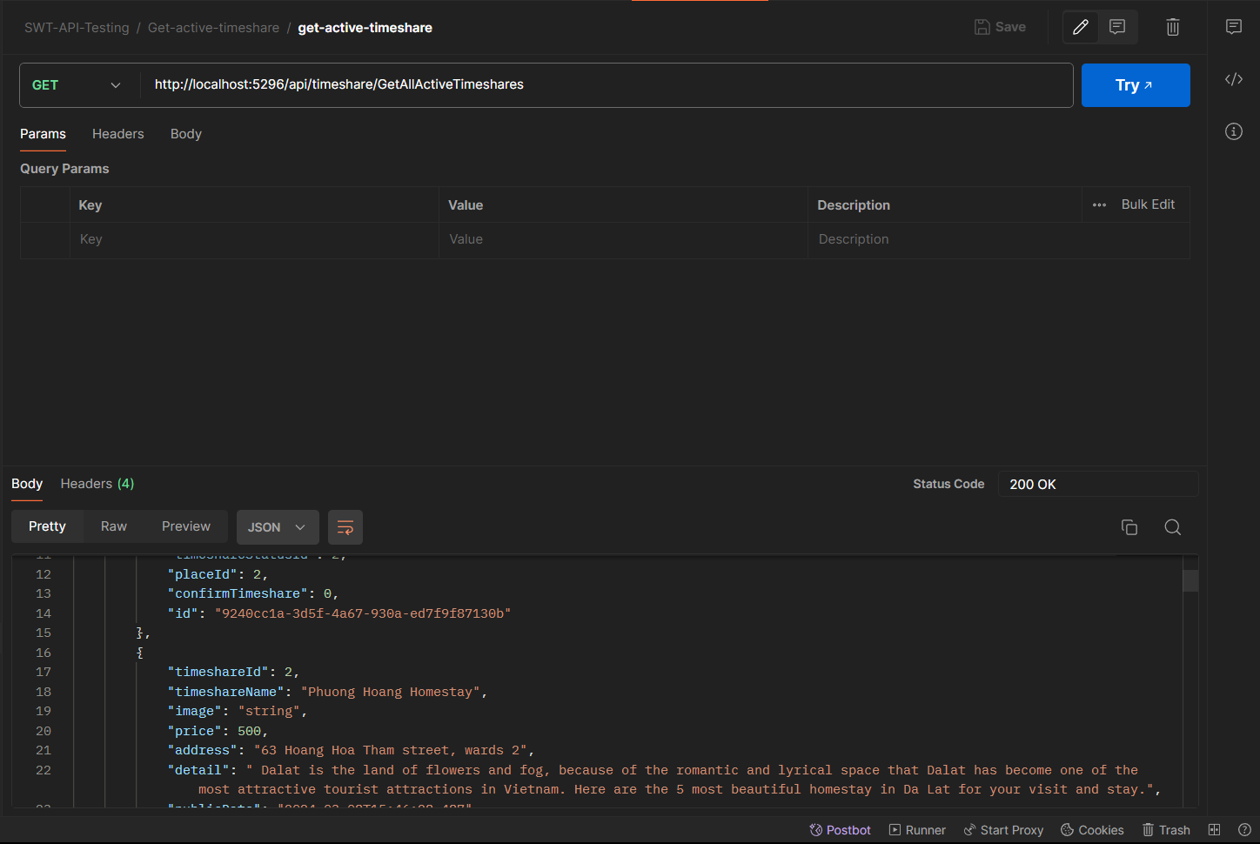

29.

30.

31.

32nb .

**Timeshare detail**

33. API Get all Timeshare Detail:

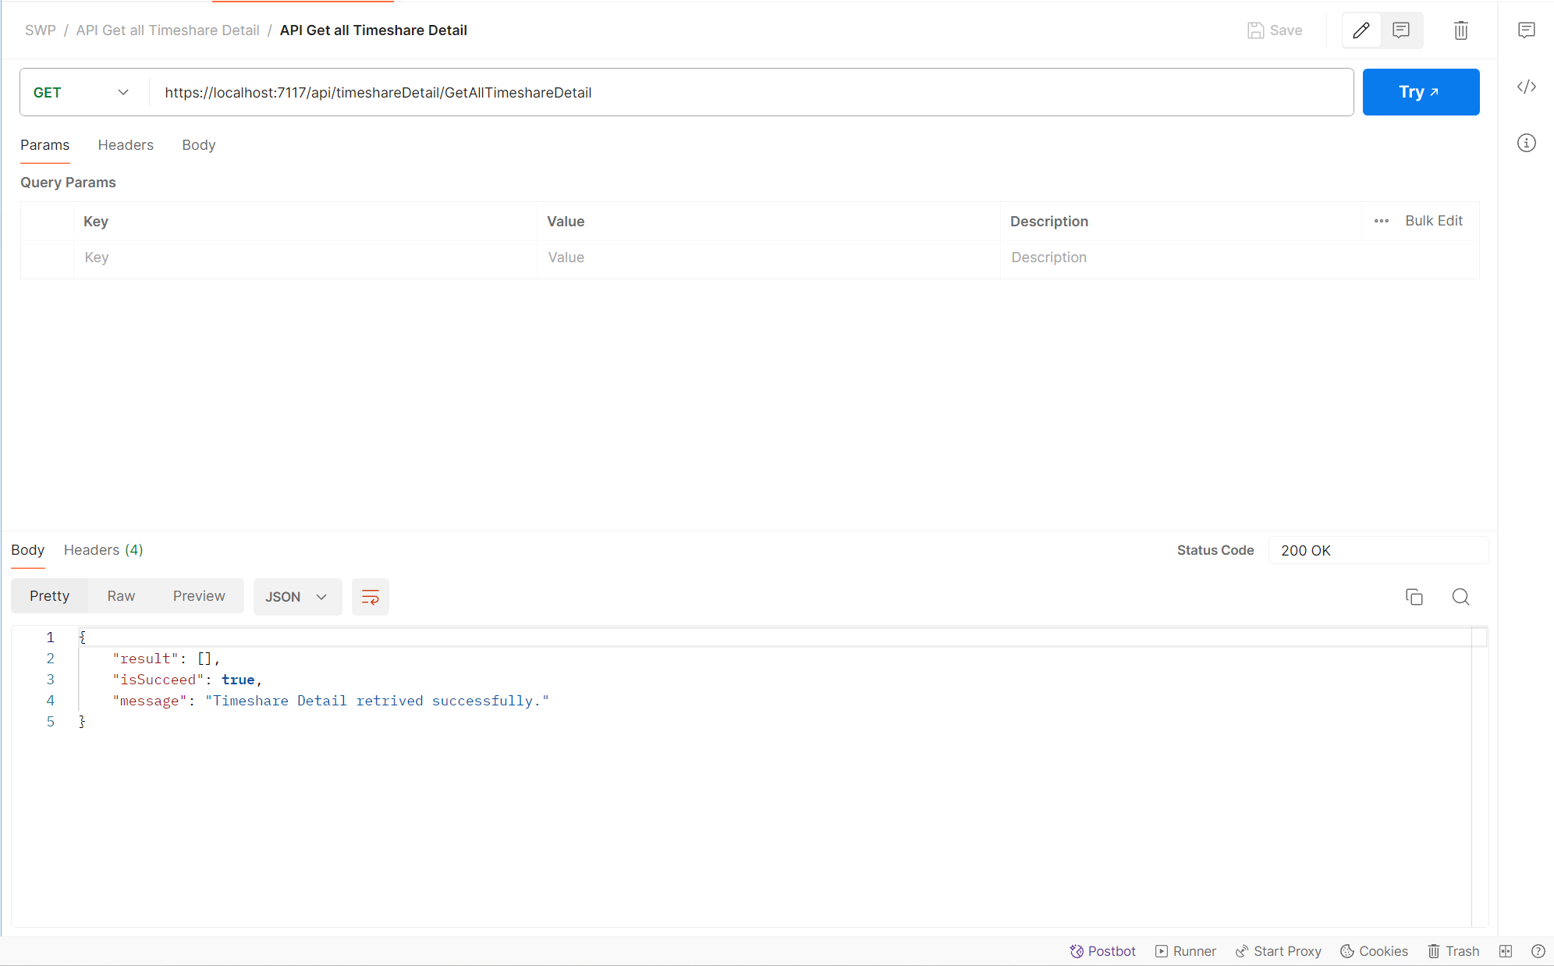

34. API Get all TimeshareDetail_ID: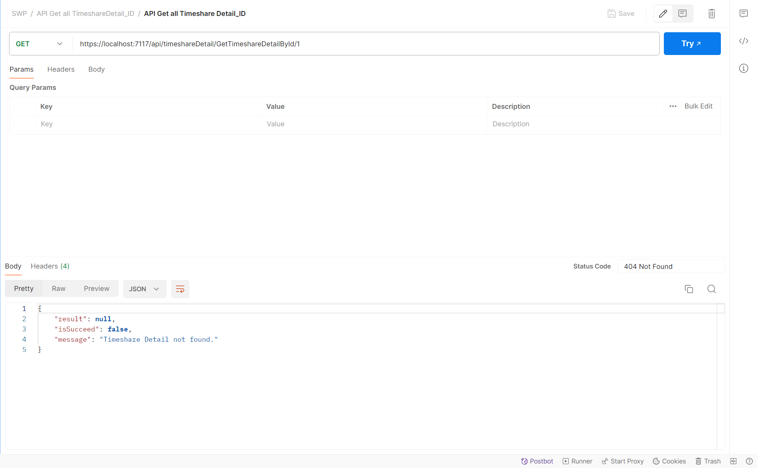

35. API Create Timeshare Detail: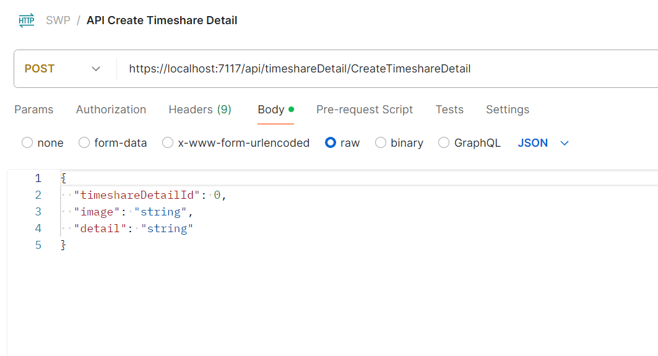

36. API Update Timeshare Detail_ID: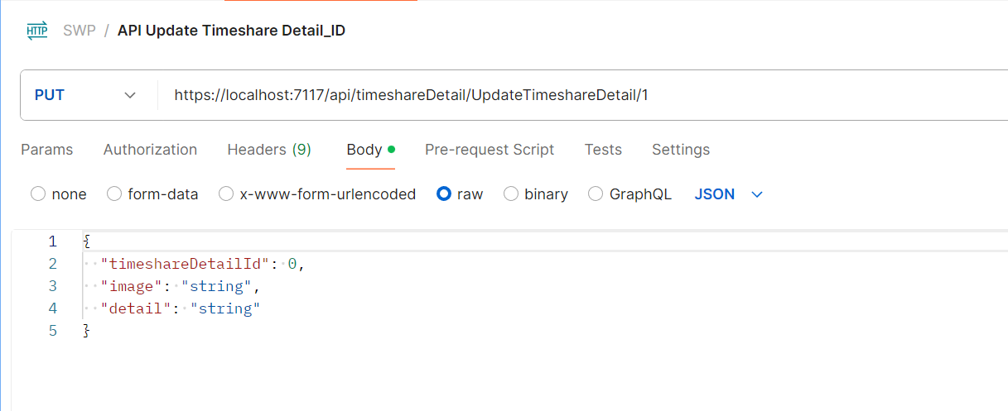

37. API Delete Timeshare Detail_ID: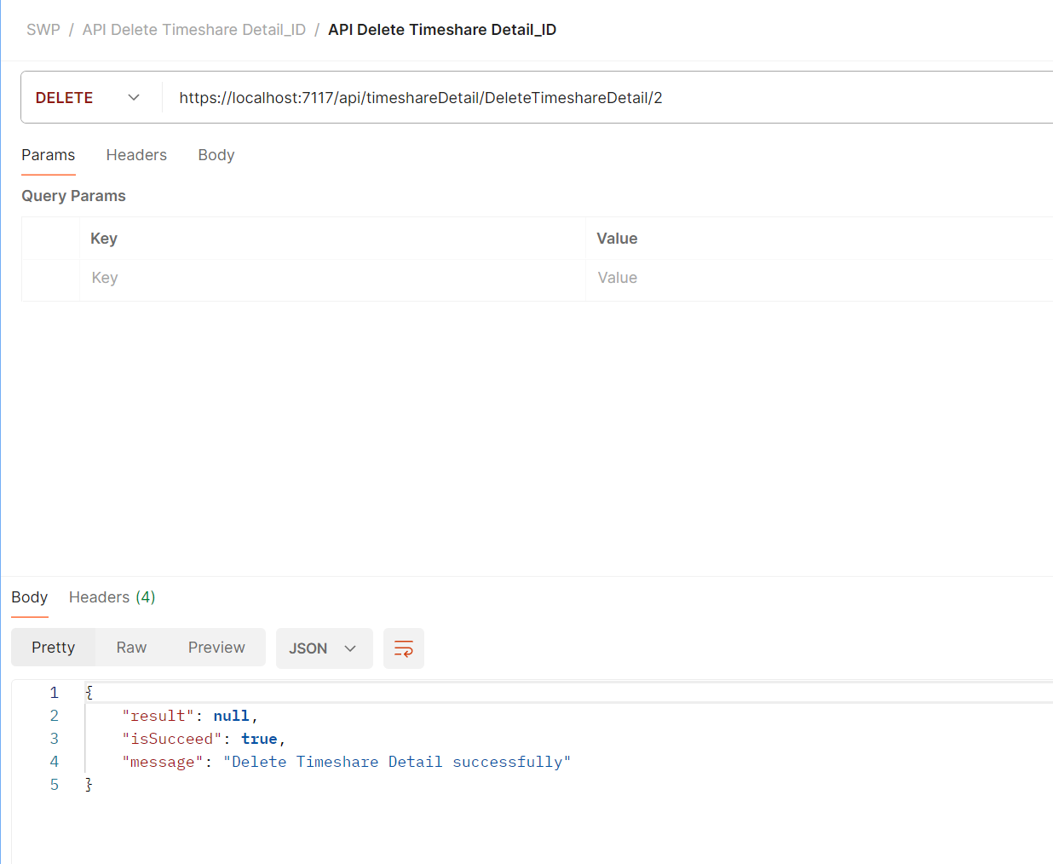

**User**

38. API-GetAllUser :

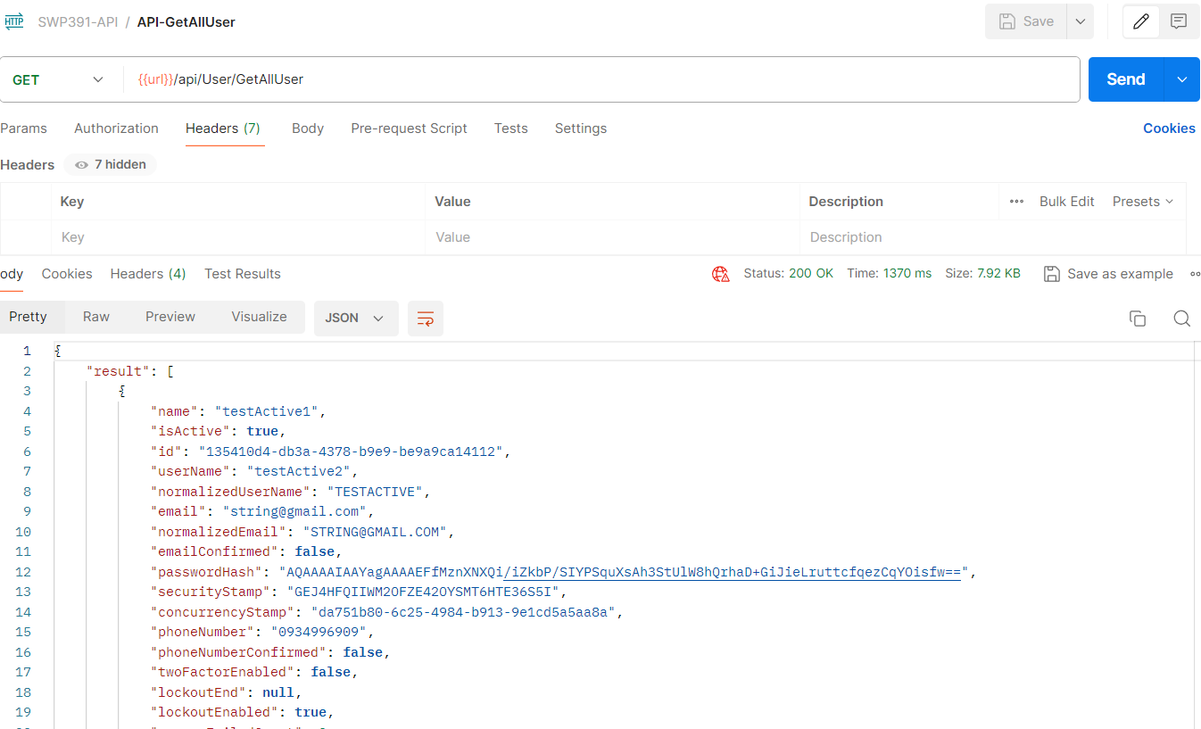

39. API-GetUserByID

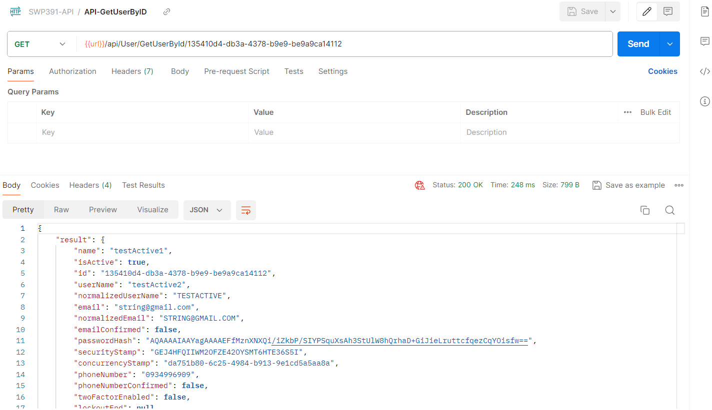

40.API-UpdateUser

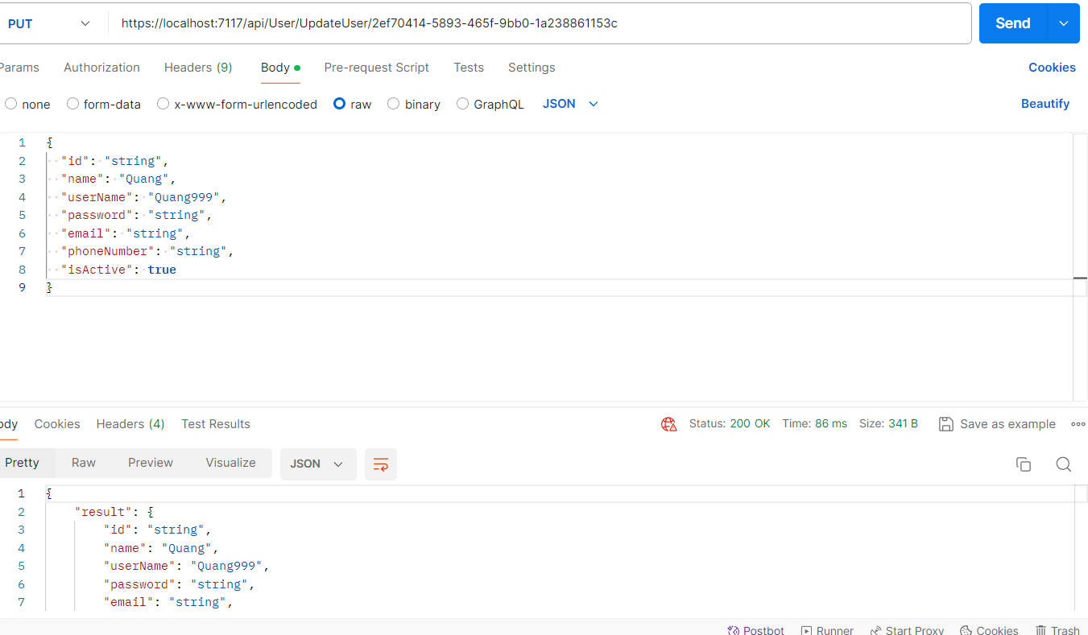

41.API-DeleteUser

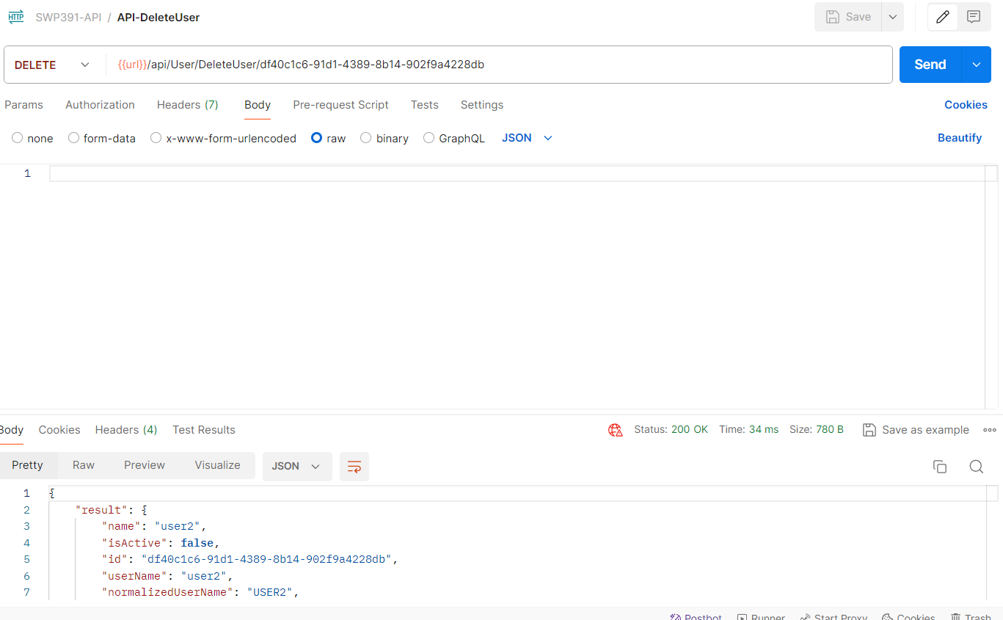

42. API-PagingUser

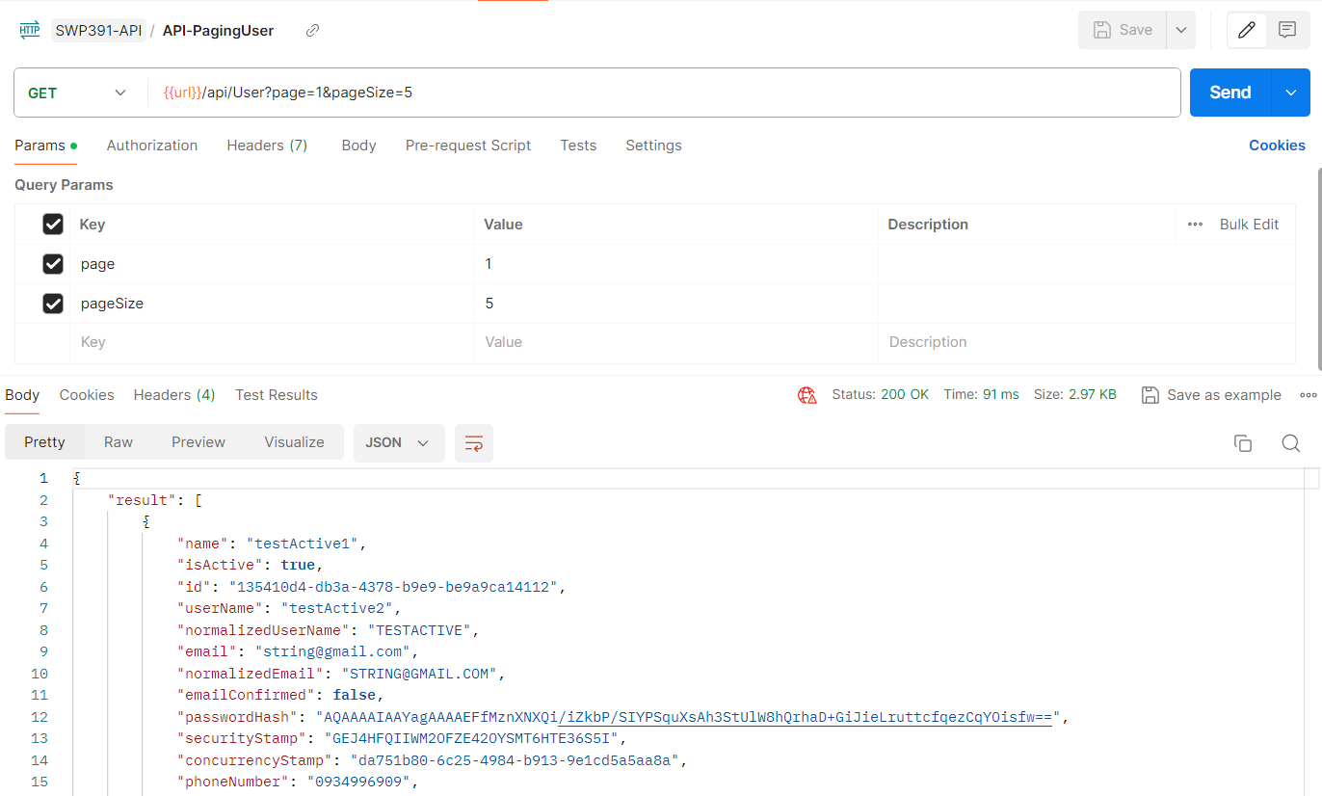

**Timeshare status**

43.API-Timeshare-Status

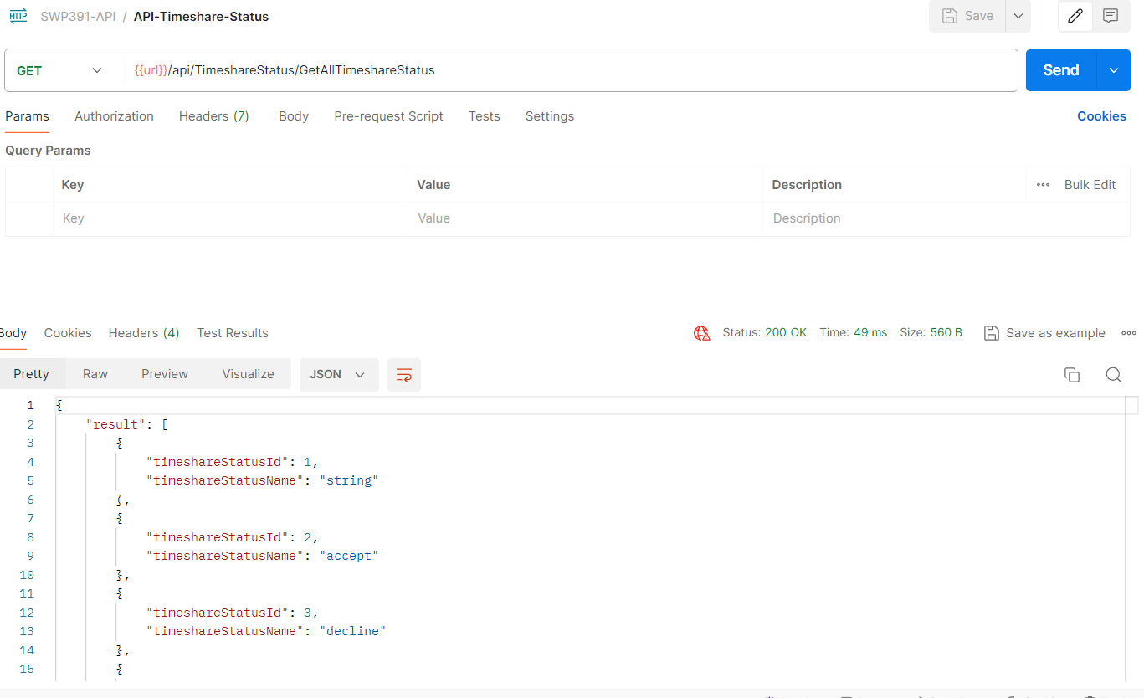

44.

API-TimeshareStatusByID

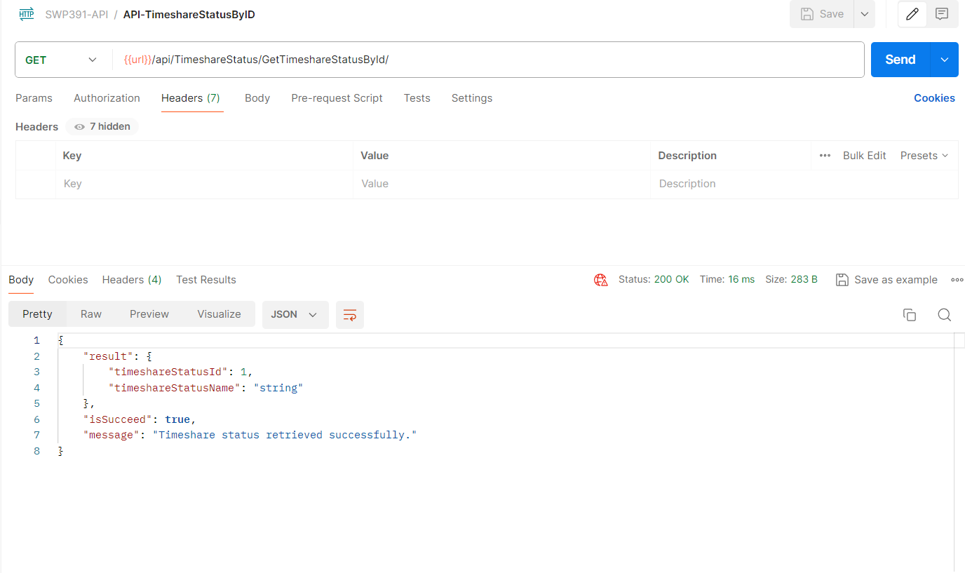

45. API-Create-Timeshare-Status

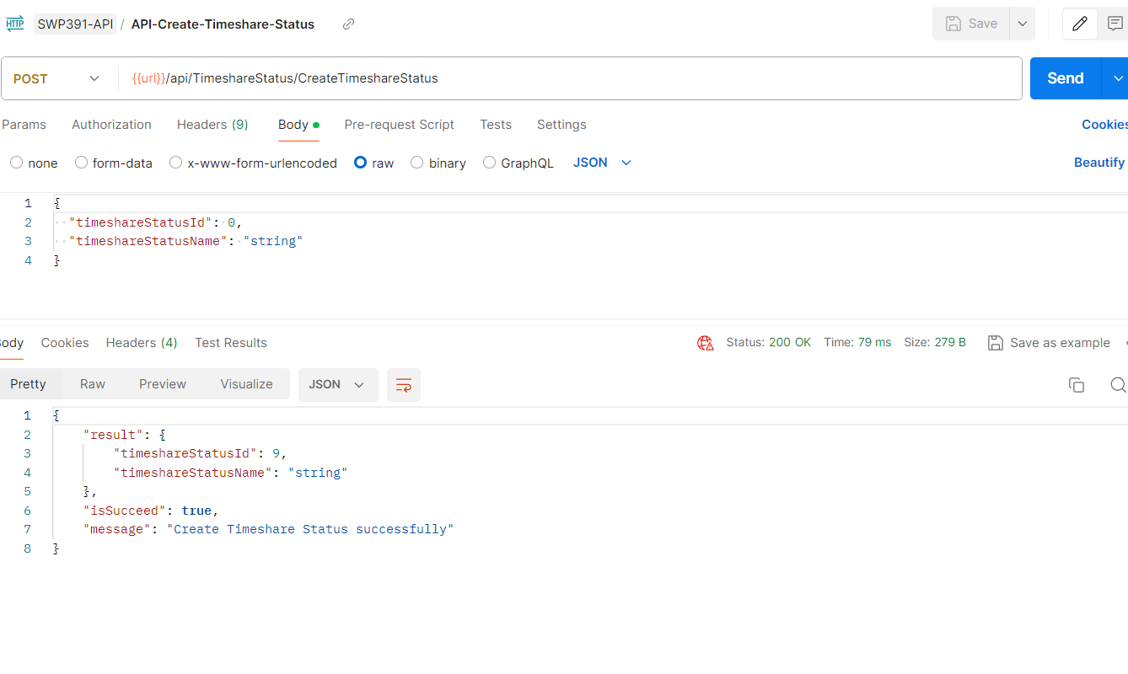

46. API-UpdateTimeshareStatus

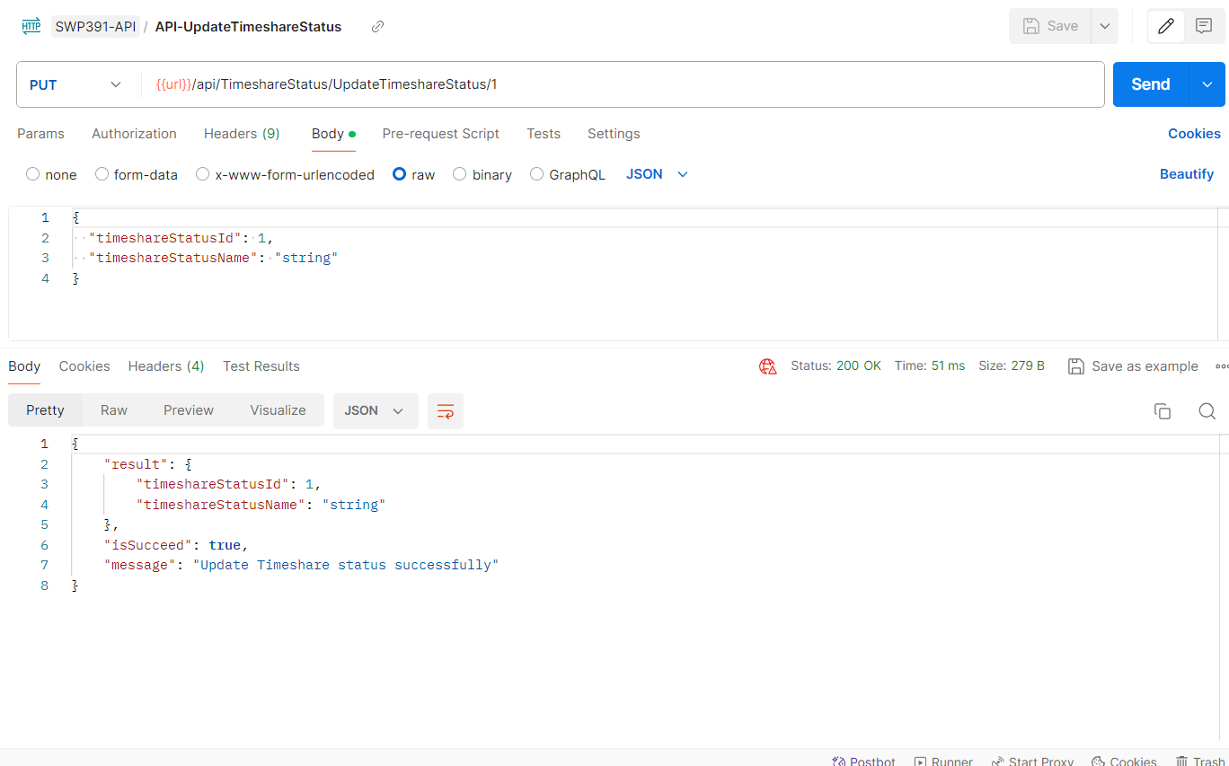

47. API-DeleteTimeshareStatus

